**SENTINELS ROBOTICS LOGBOOK**

Layer Designs (Mechanical)

# Layer 1

## [v1] Initial design

### 

* Circular design with 4 cut-outs around the edges to house motor
* Mounting holes for motors and kicker
* Re-used past kicker designs
* Holes on the front prongs, side and back of plate for mounting stand-offs that connects to other layers
* 20mm catchment area
* 1.6mm thick
* PCB

## [v2] Removed holes

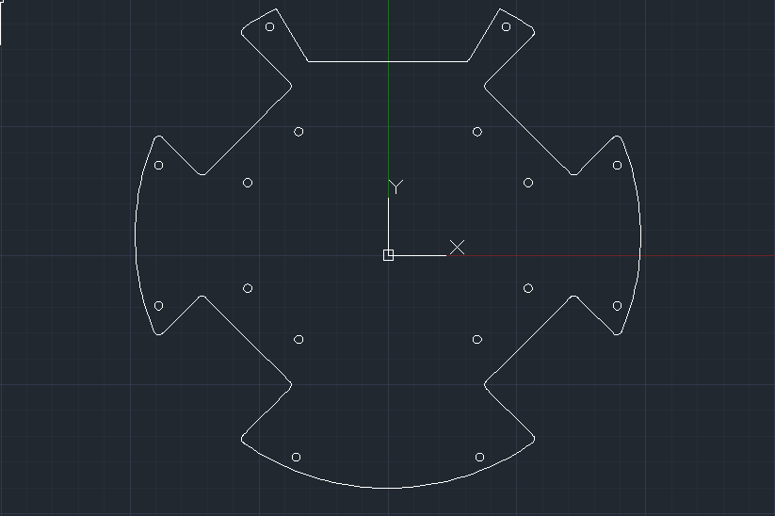

* Removed unnecessary holes previously made for kicker
  + Planned to re-design kicker mechanism

## [v3] Made cut-outs

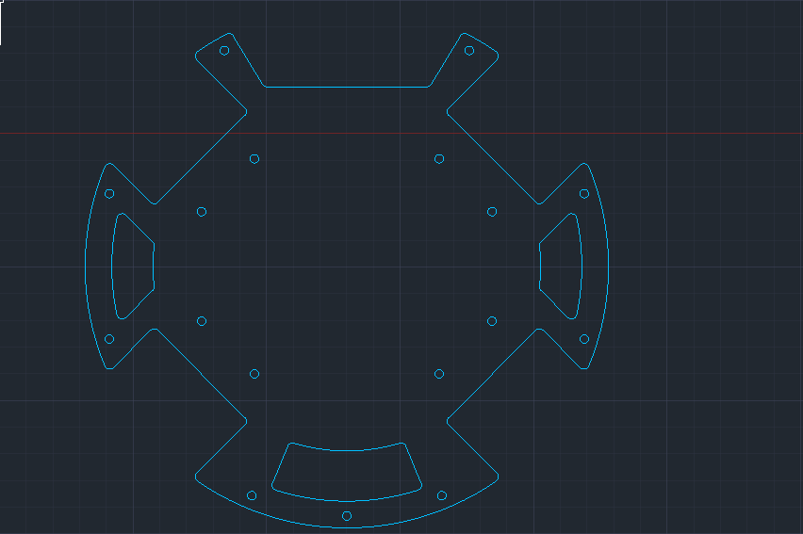

* Cut-outs were made at the side and back of plate
  + Reduce weight
  + Pass wires and cable through cut-outs

## [v4] Minor change - Not captured

## [v5] Minor change - Not captured

## [v6] Minor change - Not captured

## [v7] Minor change - Not captured

## [v8] Minor change - Not captured

## [v9] Removed cut-outs

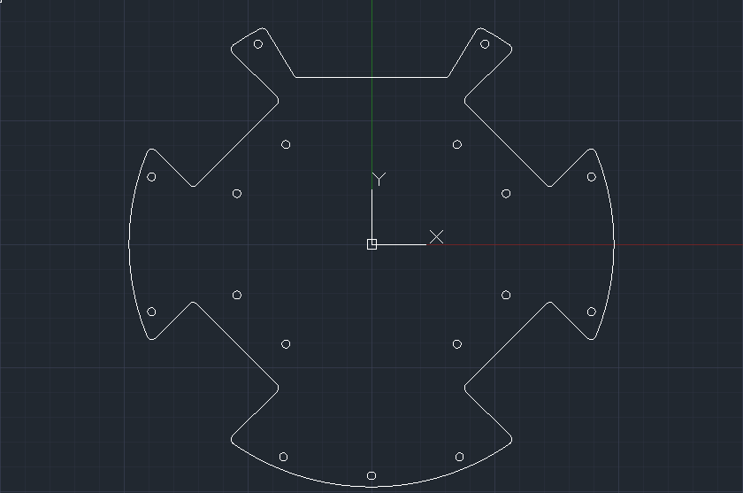

* Wanted to change cut-out design
  + Removed cut-outs first
  + Changes made later

## [v10] Increased catchment area / Added cut-outs / Made Holes

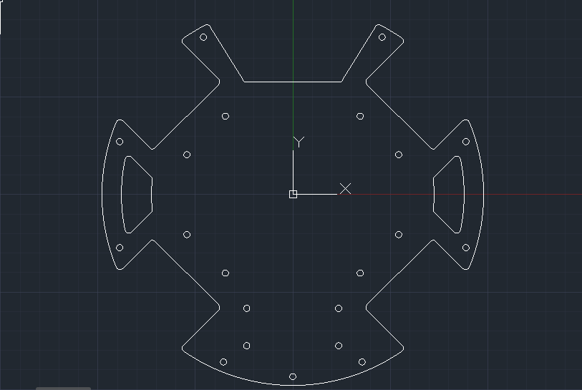

* Added cut-outs to reduce weight
* Increased size of catchment area from 20mm to 30mm
* Made 4 holes near the back for battery mount

## [v11] Edited battery mount design

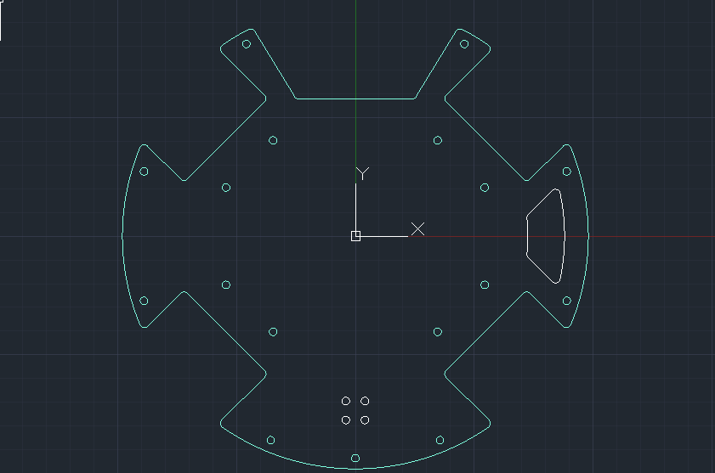

* Removed one redundant cut-out
  + Weight reduction postponed
* Battery mount holes position changed
  + Changed to elevated design
  + Battery mount was hitting a Surface Mounted Device (SMD Electronic)

## [v12] Cut-outs changed

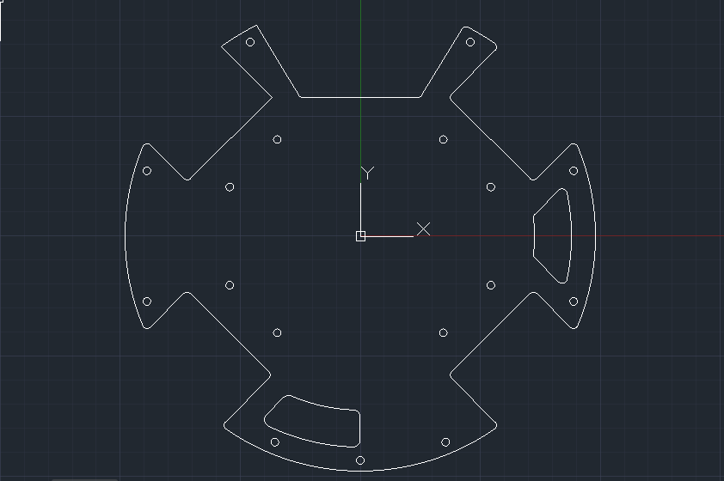

* Battery mount design changed
  + Battery mount will now be mounted on layer 2 instead
  + Made space for obstructing SMD
* Added extra cut-out for weight reduction

## [v13] Minor change - Not captured

## [v14] **FINAL:** Filleted and smoothed edges

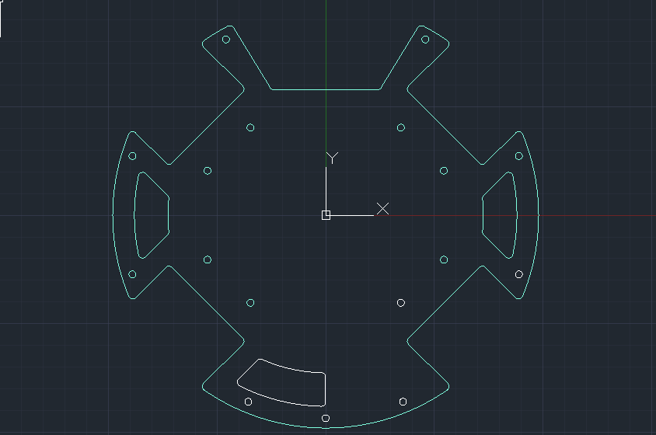

* Filleted edges of layer
* Smoothed edges

# Layer 1.5

## [v1] Initial design

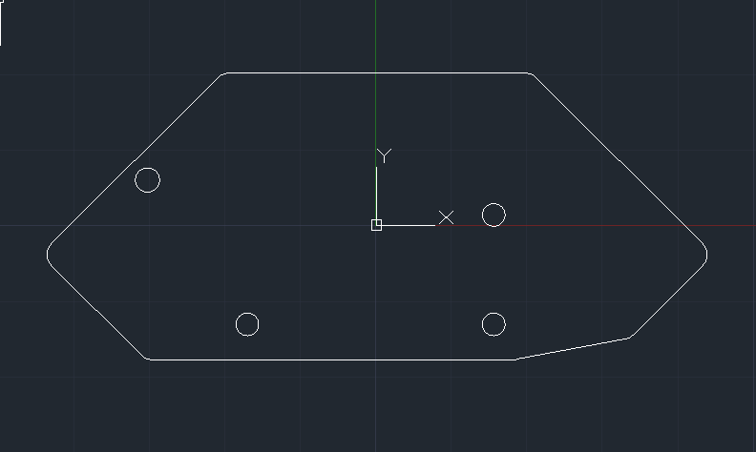

* Small layer that will replace the 2mm motor spacers between top motor mounts and layer 2 as buffer space
  + 3D Printed
* Holes made for mounting servo mount through layer 2
* Holes for screwing through layer
* 2mm thick

## [v2] Added more holes

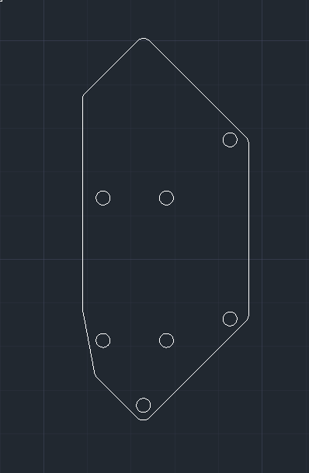

* Added more holes to mount servo mount and motor

## [v3] Made layer 1.5 symmetrical

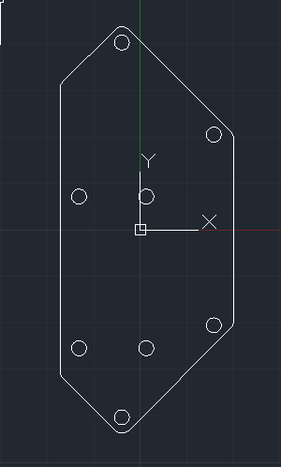

* Made 1.5 symmetrical
* Added holes motor on the opposite side

## [v4] **FINAL:** Made mesh cutouts to reduce weight

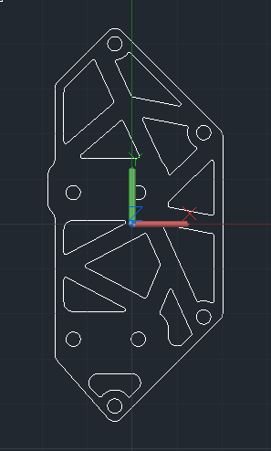

* Added area popping out
  + Make clearance for servo mount to sit on
* Made mesh cut-outs to reduce weight
* 2 clearance areas made for servo mount

# Layer 2

## [v1] Initial design

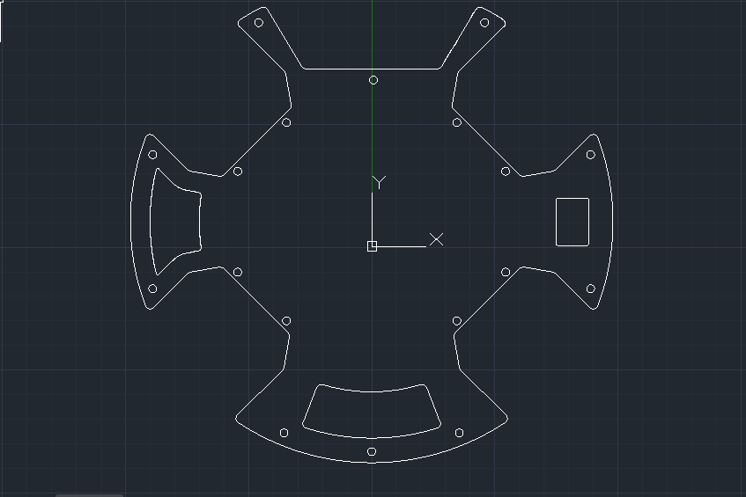

* Circular shape
* 4 large cut-outs for motors
* 20mm catchment area
* Cut-out on the left
  + Reduce weight
  + Pass wires
* Right rectangular cut-out
  + Power switch
  + 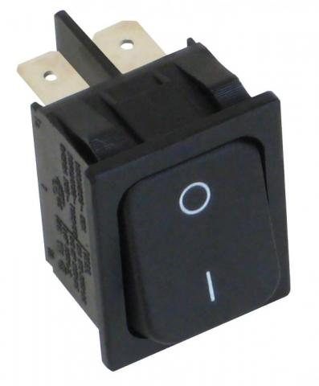
* Back cut-out
  + Reduce weight
  + Match layer 1 cut-out
* Layer 2 will not house any electronics
  + Simply a Ground (GND) plane
* PCB
* 1.6mm thick

## [v2] Made holes for kicker mount

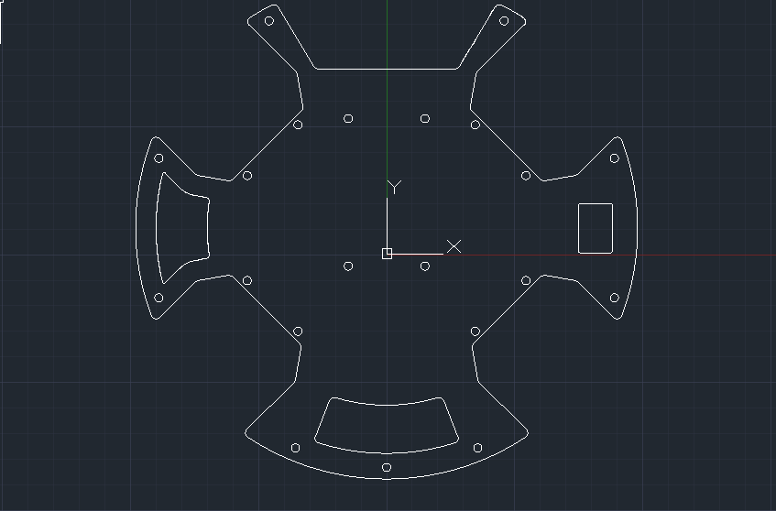

* Made holes for kicker mount

## [v3] Cut-outs and holes

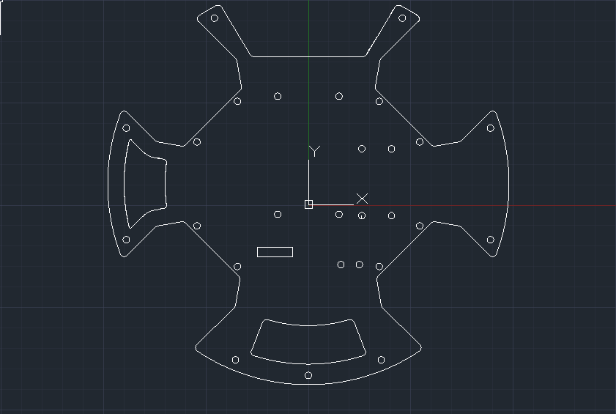

* Made rectangular cut-out for bluetooth module sticking out from layer 3
* Made holes
  + Mounting mechanism for servo
  + Other mounting holes

## [v4] Added identical cut-out on right side

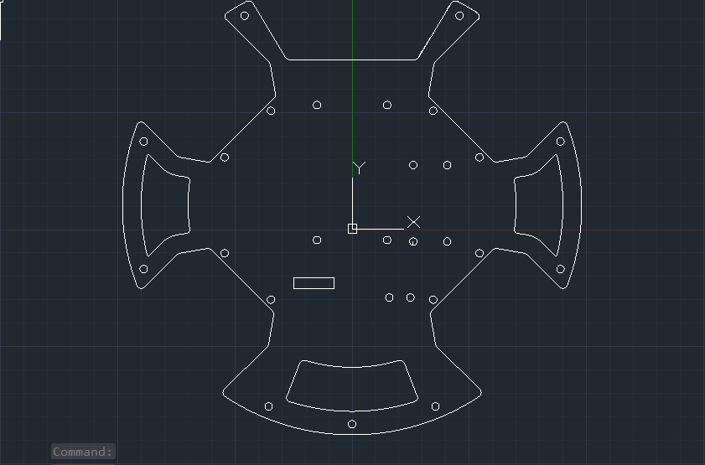

* Added another cut-out on the right
  + Identical as the left cut-out
  + Weight reduction

## [v5] Changed motor cut-outs

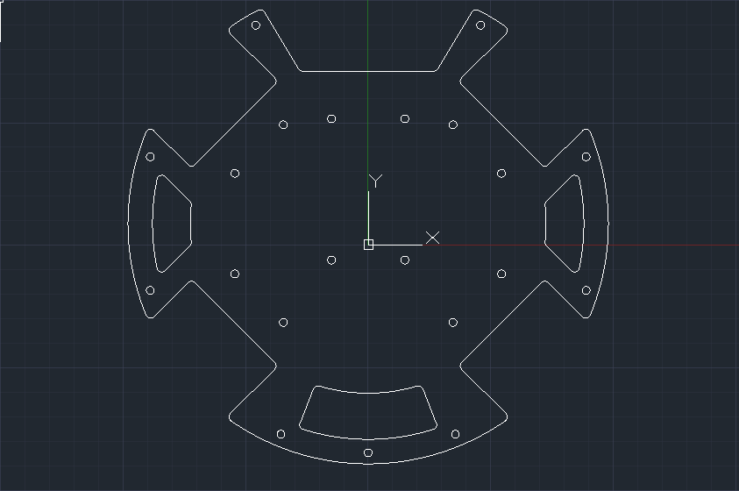

* Electronegativity from motors affected electronics on the above layers
  + Match cut-outs on layer 1
* Removed redundant holes
* Re-designed left and right cut-outs\

## [v6] Added holes for mounting limit-switch

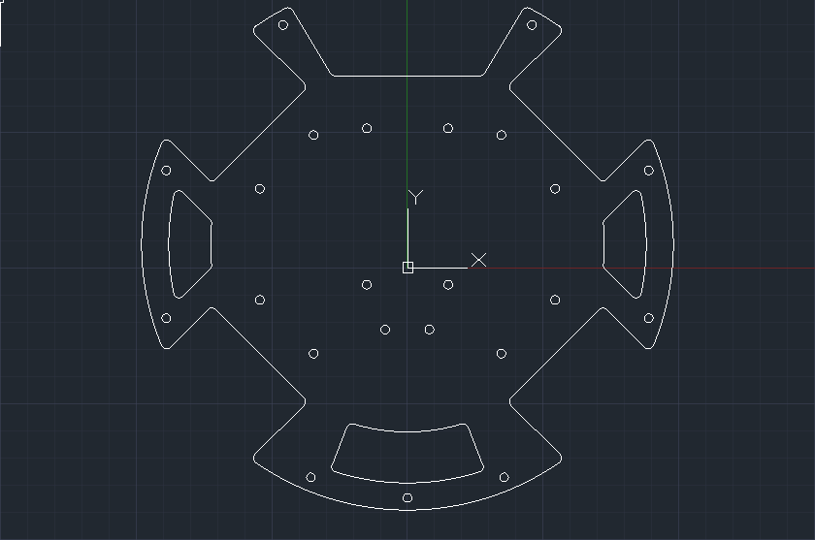

* 2 Holes made at the back for mounting limit switch
  + Simple 2-part 3d printed mount
  + 2 Holes used

## [v7] Holes and cut-outs made

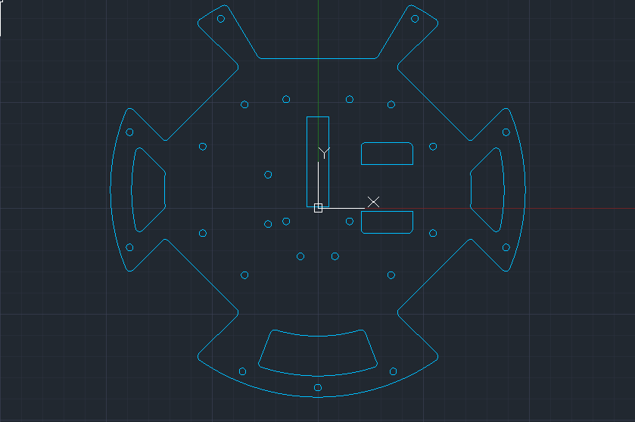

* Implemented layer 1.5
* 2 rectangular cut-outs made for servo mount to pass through layer 2 to be mounted on layer 1.5
* 2 holes made on the left for mounting of other side of servo mount
  + Will be able to house a bearing to mount axle to servo
* Long rectangular hole made in the centre
  + For gear rack on kicker to pass through from under layer 2
  + Gear will be able to engage gear rack from above layer 2

## [v8] Minor change - Not captured

## [v9] Increased catchment size / Battery mount cut-out made

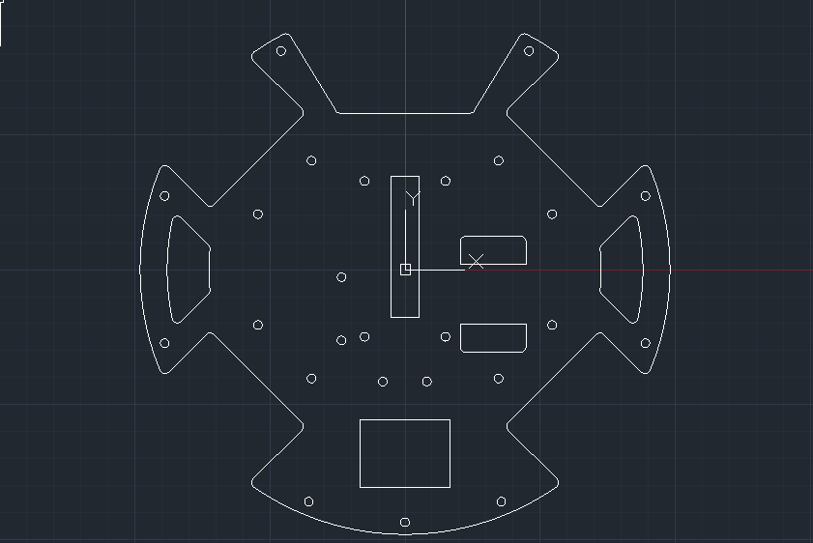

* Size of catchment area increased from 20mm to 30mm
  + Same changes made to layer 1
* Battery mount cut-out made at the back of the layer
  + For friction-fitted battery mount

## [v10] Increased gear rack cut-out length

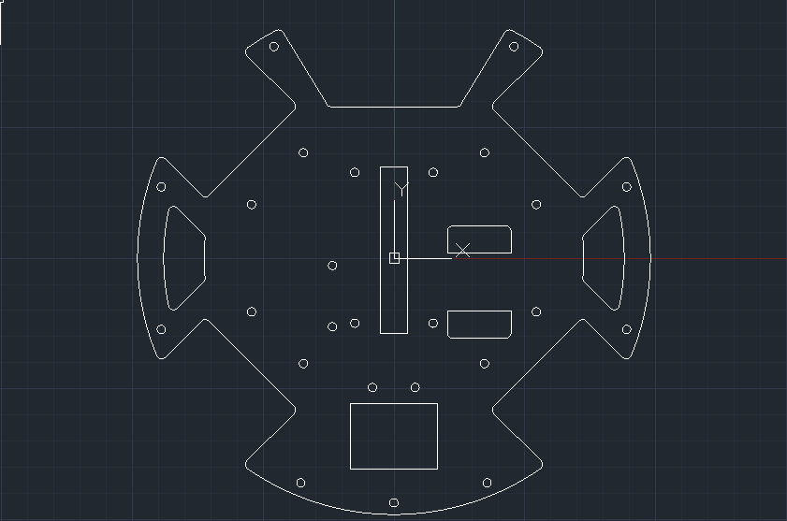

* Increased the length of the cut-out made for gear rack
  + Facilitate larger catchment area
* Moved limit switch mounting holes backwards to facilitate longer kicker

## [v11] Increased battery mount cut-out height

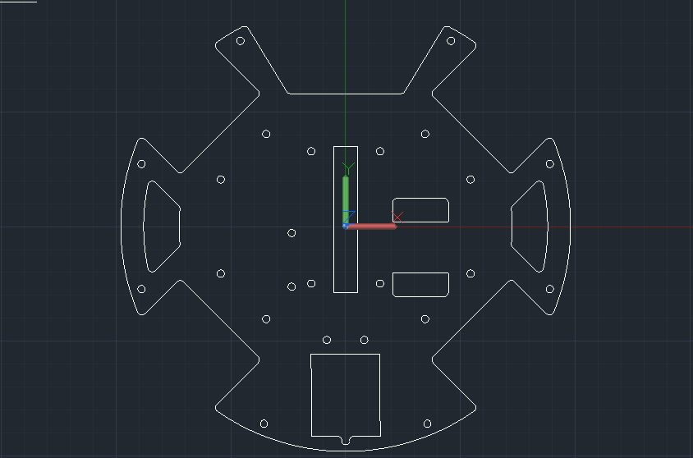

* Increased height of battery mount cut-out
  + Due to the minimal amount of tolerance at the back
  + Cut-out was too close to mounting hole for standoff at the back
  + Union hole and cut-out to prevent snapping

## [v12] Increased battery mount cut-out width

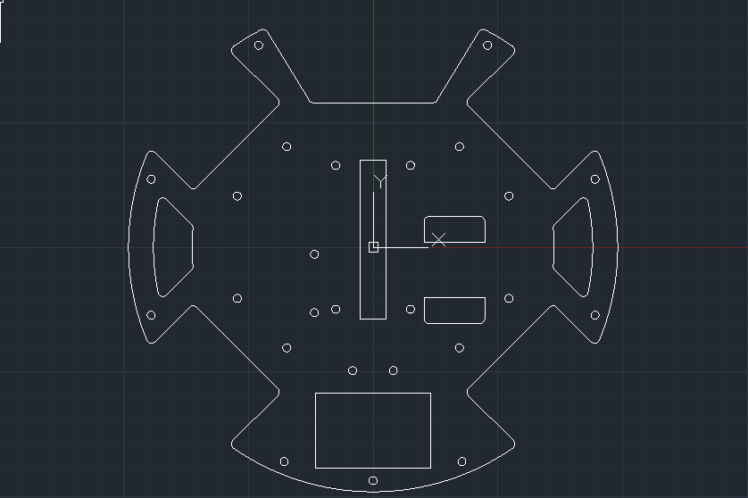

* Increased width of battery mount cut-out
  + To fit larger battery

## [v13] Added hole for jumper cable

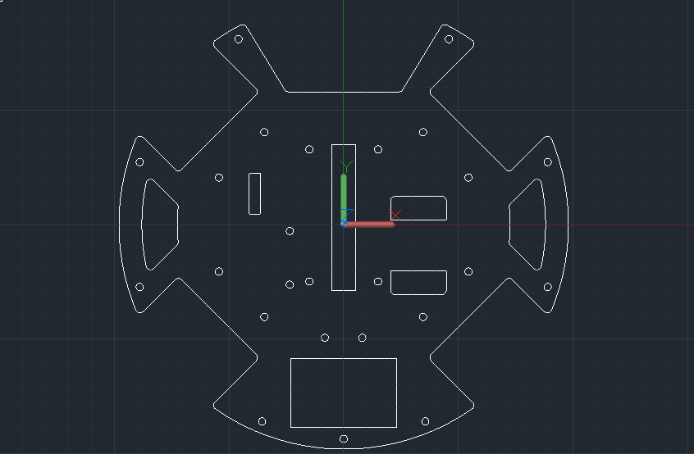

* Rectangular hole added at the top left of layer
  + Allow jumper cable to pass through from layer 1 to 3

## [v14] Enlarged cut-outs and added holes

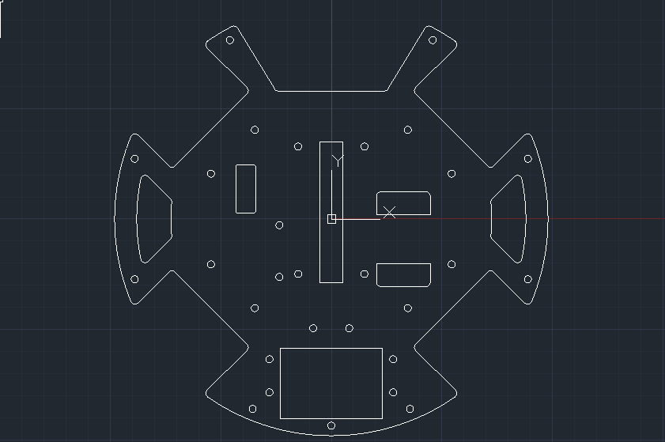

* Enlarged size of hole for jumper cable
  + Previously did not fit
* Added holes for screwless battery mount design
  + Snap-fit 3D printed prongs to fit into holes
  + Friction mounted

## [v15] Filleted cut-outs / Changed battery mount snap-fit

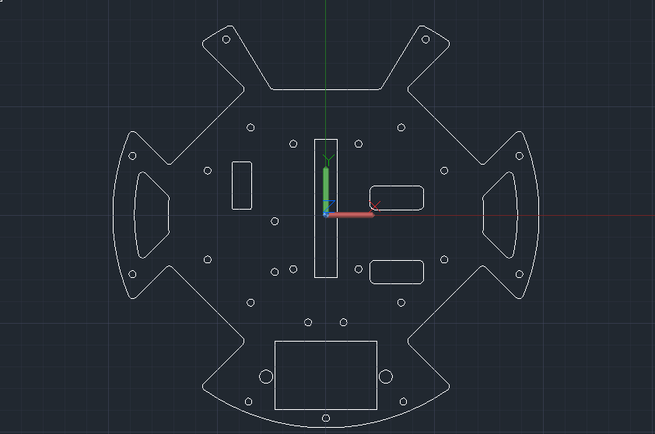

* Rounded corners of pass-through holes made for servo mount
* Instead of 4 holes for battery mount
  + Changed to 2 larger holes
  + Tighter fit
  + Simpler design

## [v16] **FINAL:** Changed multiple cut-outs

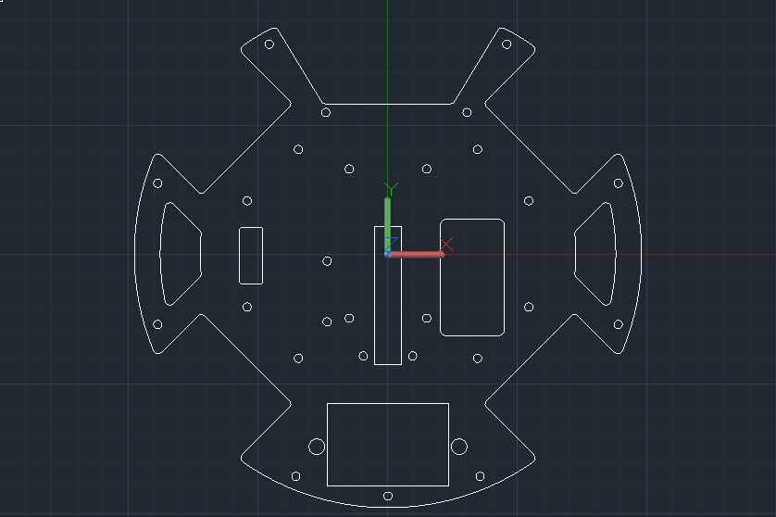

* Merged 2 pass-through cut-outs for servo mount
  + Reduce weight
  + Easier fit
* Moved entire kicker gear rack cut-out backwards
  + Gear was not engaging gear rack originally
  + To facilitate new kicker gear rack design
* Moved limit switch mounting holes forward
  + Kicker had a chunk cut-off so that the limit switch can be engaged nearer to the front
  + Old limit switch placement was hitting battery mount

# Layer 3

## [v1] Initial design

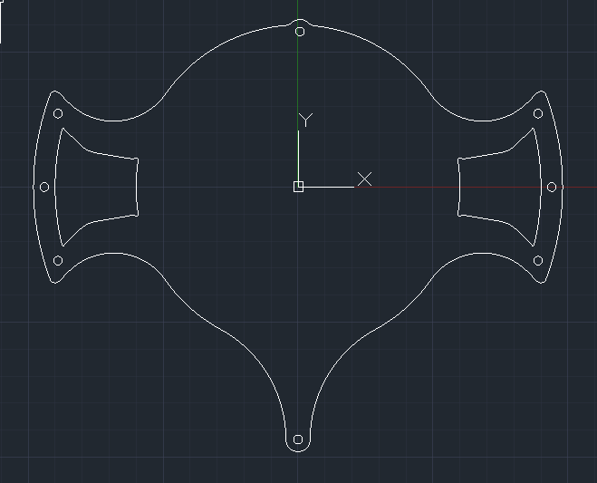

* Double circular design
* Holes for standoffs for mounting to layer 2 and 4
* Cut-outs to reduce weight
* Protution at the bottom
  + With hole to mount standoffs to layer 2
* PCB
* 1.6mm thick

## [v2] Removed mounting hole at the top

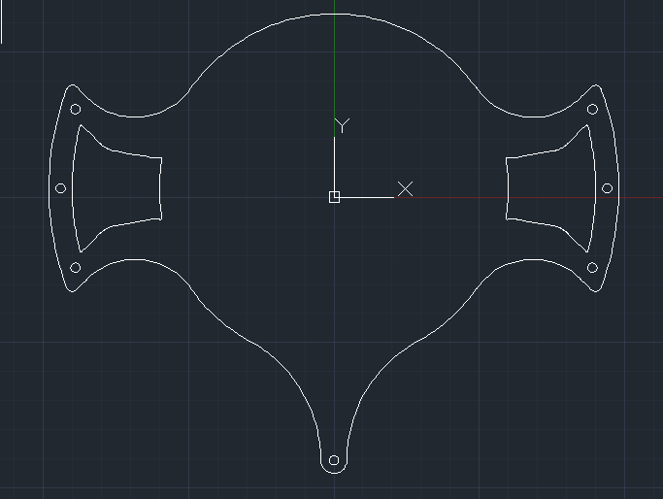

* Removed mounting hole for standoff the back of the layer
  + Redundant

## [v3] Added holes

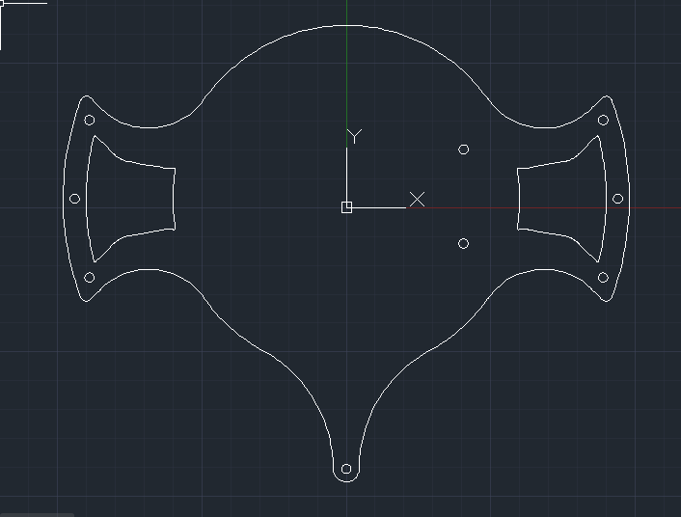

* Added 2 holes for servo mount
  + Servo mount is sandwiched between layer 2 and 3 with a friction fit

## [v4] Removed servo mount holes

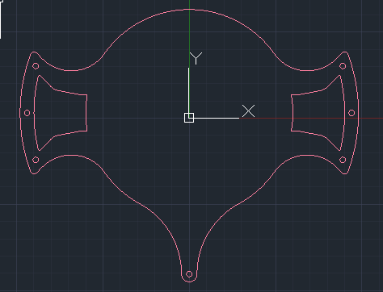

* 2 servo mount holes removed
  + Servo mount designed changed to be mounted on layer 2 only
  + Reduce print material
  + Reduce weight

## [v5] Minor change - Not captured

## [v6] Smoothed edges and fixed line overlap issue

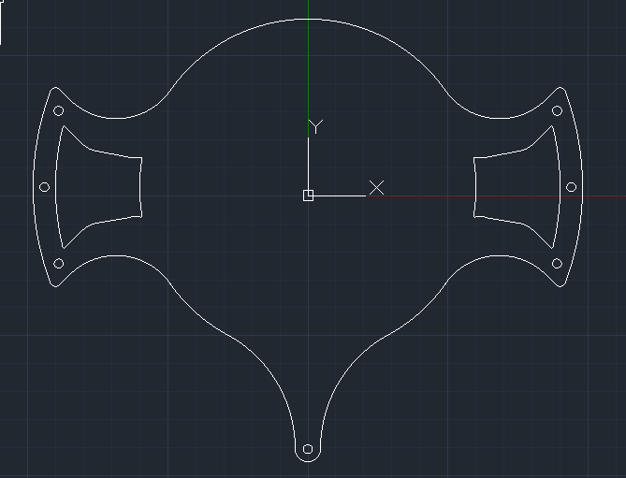

* Smoothed lines
  + Changed from splines to polylines
* Splines were not recognised by EAGLE (PCB design software)
  + Retraced layer into polylines

## [v7]Filleted cut-outs

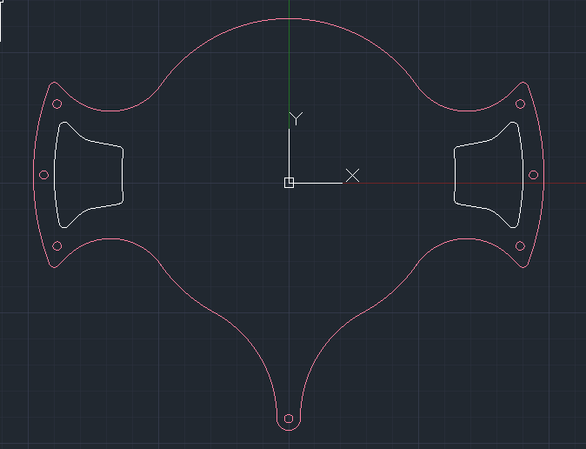

* Smoothed the corners and edges of cut-outs on left and right

## [v8] **FINAL:** Made cut-outs to reduce weight

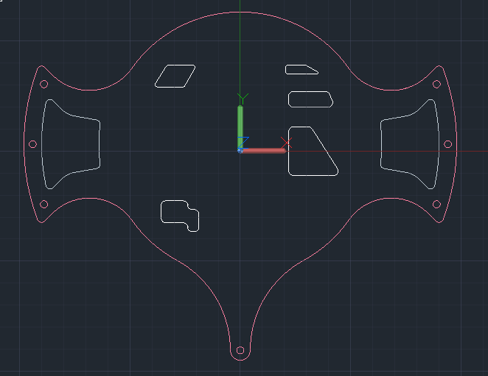

* Cut-outs made in area that were not interfering with electronics
  + Reduce weight

# Layer 4

## [v1] Initial design

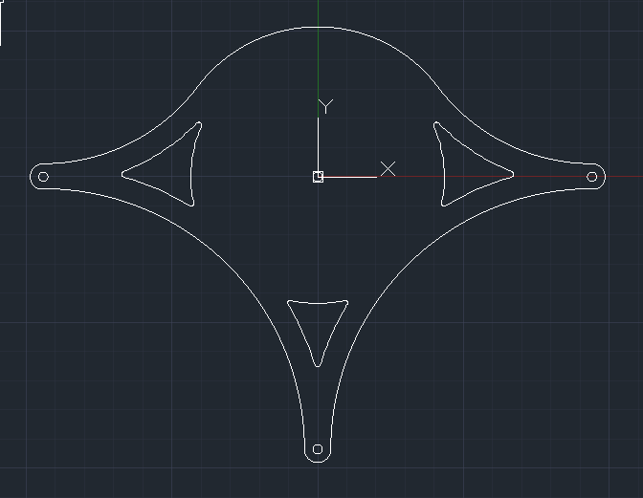

* Circular centre
* Bottom left and right areas
  + Circular cut-outs
* Centre area for mounting area
* Unoccupied area
  + Made cut-outs to reduce weight
* Hole in centre to screw down mirror
* 1.6mm thick

## [v2] Minor change - Not captured

## [v3] Minor change - Not captured

## [v4] Cut-outs to reduce weight

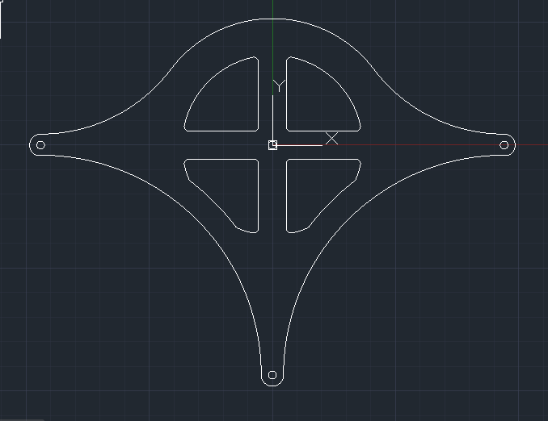

* Quarter cut-outs to reduce weight
* Kept “plus” shape to have a hole in the centre
  + For screwing down mirror

## [v5] Switched to 3D printed design

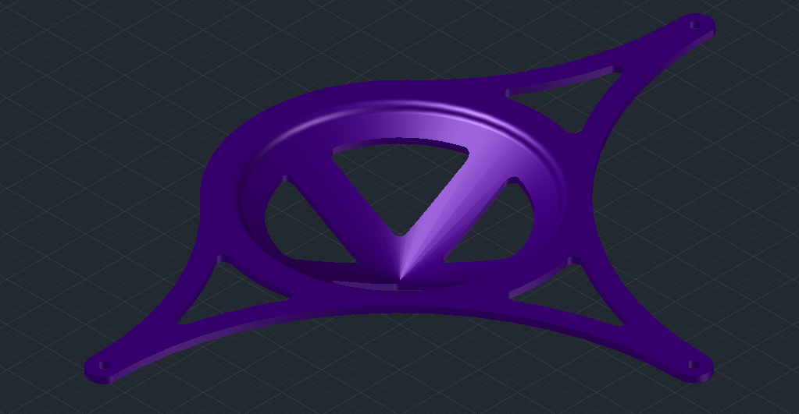

* Switched from a PCB layer to a 3D printed layer
  + Reduced weight
  + Decided to not house any electronics on layer 4
* Sinked down “plus” shaped design for mounting mirror sheet\
  + Reduce weight
  + Stronger structural integrity
* Cut-outs around the side to reduce weight

## [v6] **FINAL:** Switched back to PCB design for ultrasonic sensors

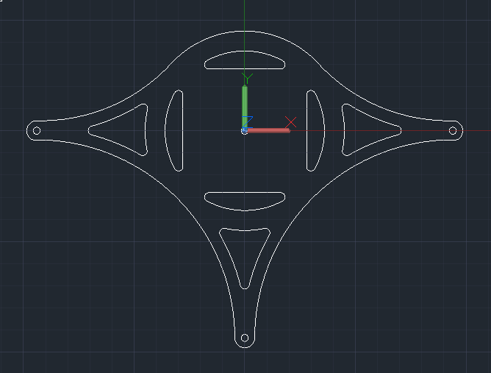

* Decided to mount 4 ultrasonic sensors on layer 4
* Switched back to PCB design instead of 3D printer to house electronics
* 3 cut-outs at the side and 4 around the circular area
  + Reduce weight

# Handle

## [v1] **FINAL:** Initial design

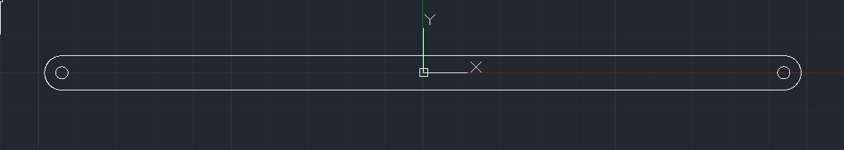

Mechanical (Layer 1): Slope

# Ball Slope

## [v1] Initial design

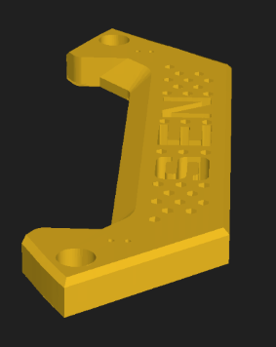

* C shaped slot design
* 2 holes for fitting onto standoffs connecting layer 1 and 2
  + No need for screws
  + Reduce weight
* Prevent ball from shaking too much when being dribbled

## [v2] Added mounting to motors

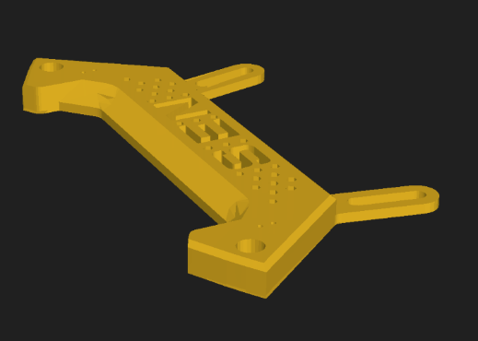

* Added 2 protrusions at the back
  + Stronger 4 point mount
  + Long cut-out in protrusion to give some linance for screws
  + Replaces 2mm motor spacers between motor and layer 1 as buffer space

## [v3] **FINAL:** Finishing touches

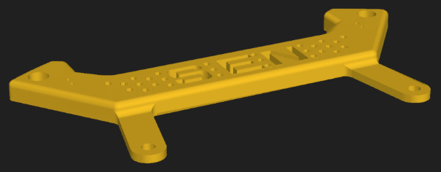

* Long cut-out on protrusion not strong enough
  + Changed to 2 holes for tight fit
* Increased width of slope
  + More space for ball
* Decreased hole size for standoff
  + Tighter fit on top standoff

Mechanical (Layer 2): Kicker

# Kicker

## [v1] Initial design

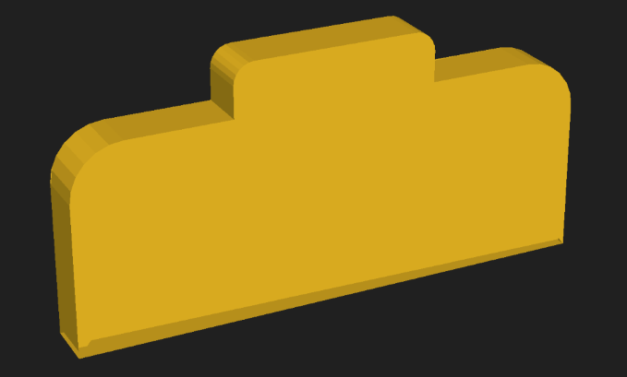

* Design from last year
* Flat face to engage ball
* Servo fibonacci spiral slip design
* Rubber banded for tension
* Force was uneven and sliding was not smooth

## [v2] Standoff through kicker design

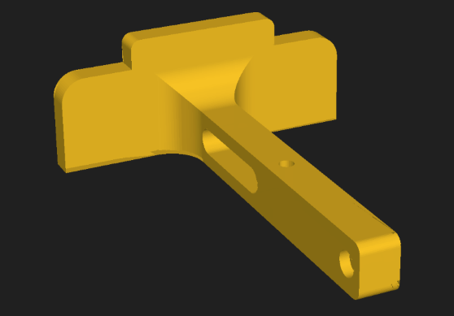

* Standoff passes through slit
* First set of standoffs mounted to kicker mount
* Back set of standoffs mounted to kicker
  + Slides along slit on kicker mount
  + Double slide mechanism

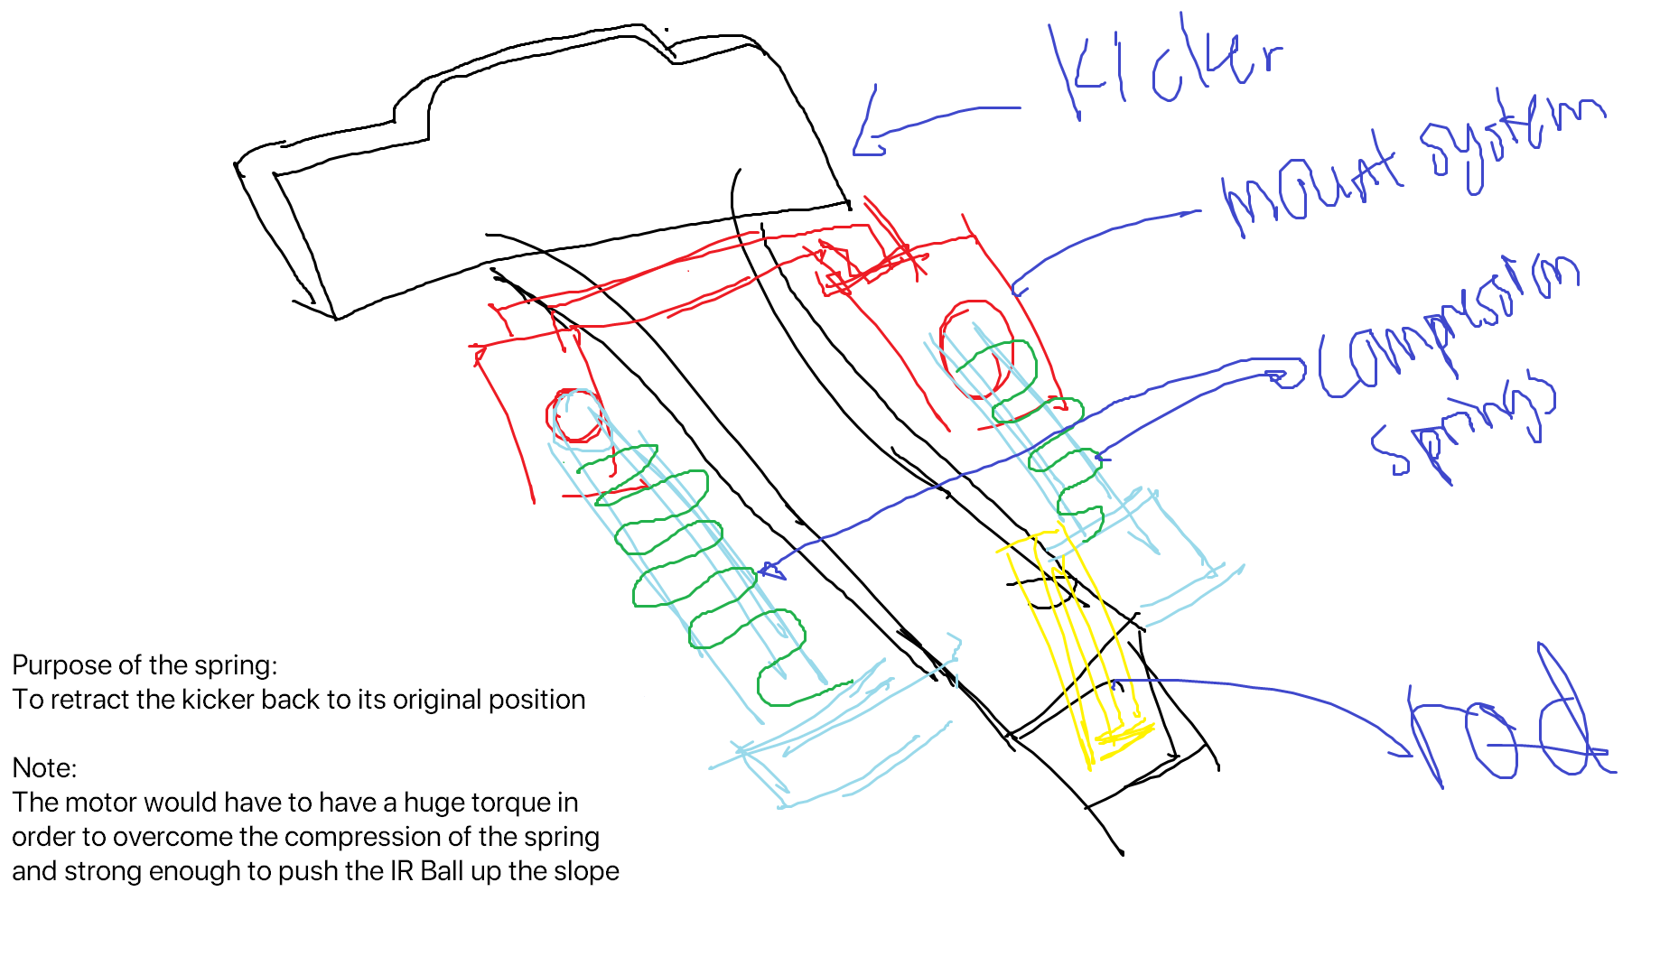

* Compression springs

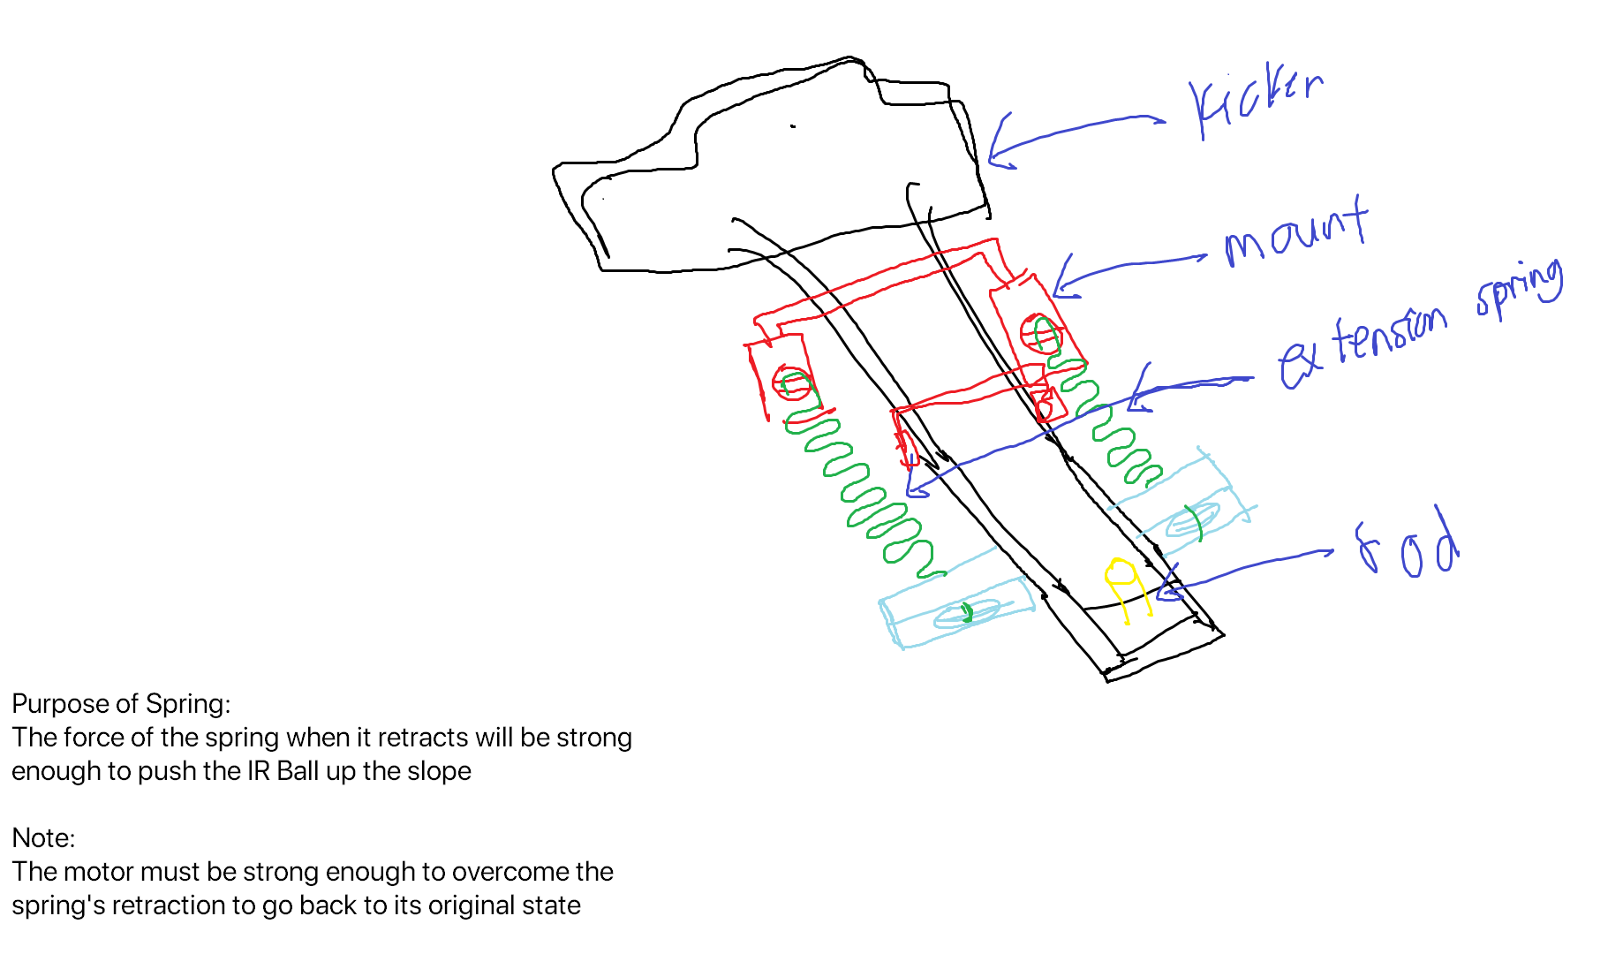

* Extension spring
  + Went with

## [v3] Slip gear design

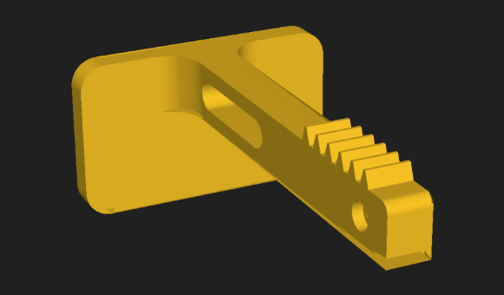

* Added gear rack on top of kicker
* Gear rack passes through layer 2 from the bottom
* Gear engages gear rack at the top of layer 2
* Keeps double slide design
* Spring powered
  + Spring hooked between 2 standoffs
  + 2 sets of springs
  + 1 on each side

## [v4] Added protrusion to hit limit switch

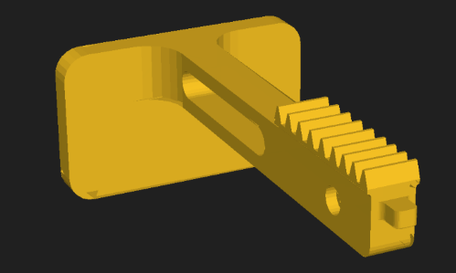

* Added protrusion at the back of kicker
* Hit limit switch
* Limit switch enable detection of kicker in loaded position

## [v5] Added cut-outs to reduce weight

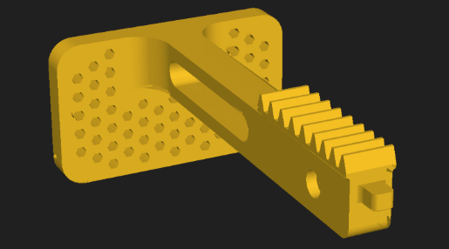

* Added cut-outs on front face to reduce weight
* 3D prints came out very bad
* Not smooth

## [v6] Increased length

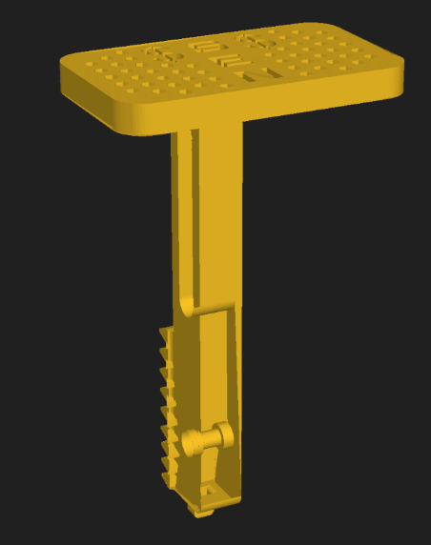

* Increased length for 30mm catchment area
* Longer slit cut-outs
* Increased gear rack length for longer displacement

## [v7] Better cut-outs

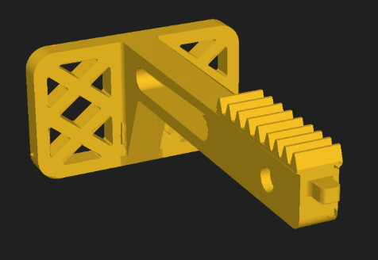

* Added criss-cross shaped cut-outs
  + Cuts more weight
  + Better structural integrity

## [v8] Initial design

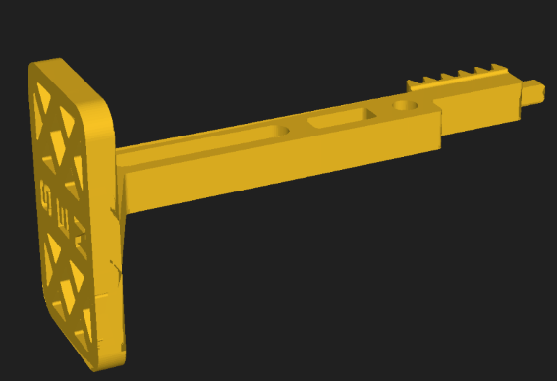

* Rectangular cut-out to reduce print material
  + Reduce weight
* Chunk removed at the back
  + Reduce weight
* Revamped gear rack system for move accurate slipping point
* Increased length of protrusion to hit limit switch

## [v9] Increased clearance for standoffs and top

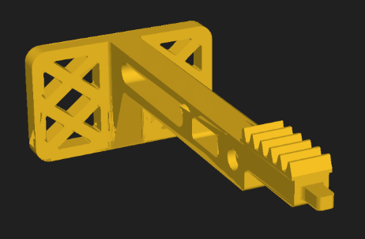

* Standoff was not sliding smoothly along slit
  + Slightly increased size of slit
  + Smoother sliding
* Kicker was not sliding smoothly along the layer
  + Slightly lowered the height of top
  + Less friction against layer
* Limit switch was still hitting battery mount
  + Had to shorten kicker to allow kicker to engage limit switch earlier

## [v10] **FINAL:** New engagement system for limit switch

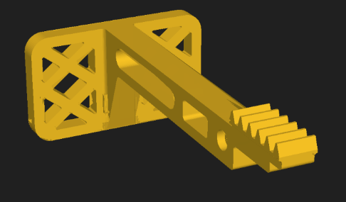

* Fixed issue of limit switch mount obstructing battery mount
* Use cut-out area below kicker to engage the limit switch
  + Allows kicker to be shortened
  + Now able to shift limit switch mount forward
  + No longer obstructs battery mount

# Kicker Mount

## [v1] Initial design

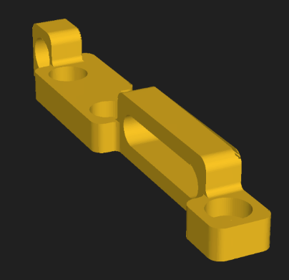

* Long slit cut-cut for standoff sliding
* Hole for screwing down standoff at the back
* Compliments the double slide system on kicker
* 3 mounting holes for screwing down to plate

## [v2] Removed extra hole

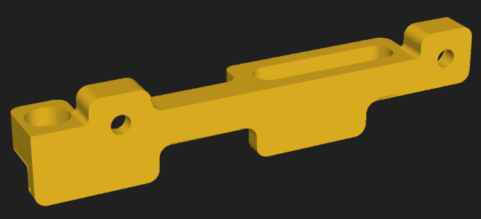

* Removed one hole
  + 2 screw mount
  + Reduce weight

## [v3] Added glider for kicker

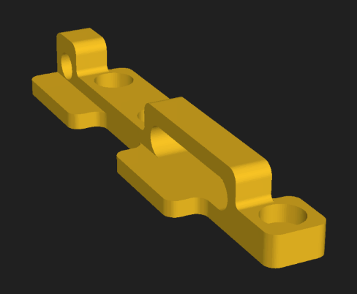

* Added 2 glider protrusions for smoother gliding for kicker
* Kicker had a problem of sliding of the 2 separated glider sometimes

## [v4]Changed to 1 large glider / Reduced height of glider

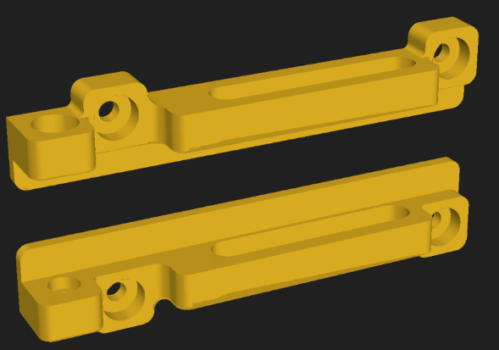

* Switched to one large glider
  + Smoother sliding
* Lowered height of glider
  + Less friction
  + Reduces some weight

## [v5] **FINAL:** Merged limit switch mount with kicker mount

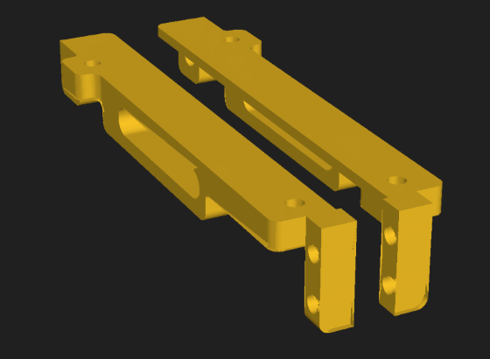

* Limit switch mount merged with kicker mount
  + Less screws for mounting
  + Reduce weight

# Source of Force

## [v1] Initial Design

* Regular red rubber band

## [v2] **FINAL:** Spring

* Springs in Parallel
  + 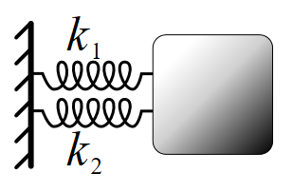
  + Springs in parallel ensemble a common strain, and the stress of the ensemble is the sum of their stresses
  + Using springs in parallel provides more force
* Springs in Series
  + 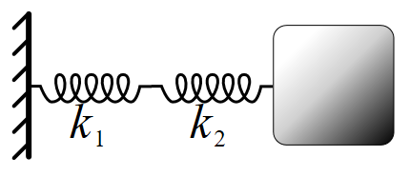
  + Springs are in series when any external stress applied to the ensemble gets applied to each spring without change of magnitude, and the amount strain (deformation) of the ensemble is the sum of the strains of the individual springs.
  + Springs in series provide a longer stretch distance
* We decided to use springs in parallel
* Provide more force over a shorter distance
* Kick the ball further
* Spring **1** specifications:
  + Wire diameter: 0.4mm
  + Diameter of Spring: 4mm
  + Length of Spring: 22mm
  + 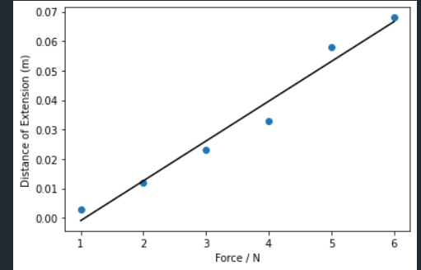
  + Gradient: 0.014
* Spring **2** specifications:
  + Wire diameter: 0.4mm
  + Diameter of Spring: 4mm
  + Length Of Spring: 17mm
  + 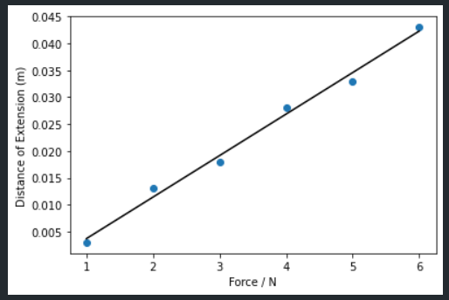
  + Gradient: 0.008
* Spring **3** specifications:
  + Wire diameter: 0.4mm
  + Diameter of Spring: 5mm
  + Length Of Spring: 15mm
  + 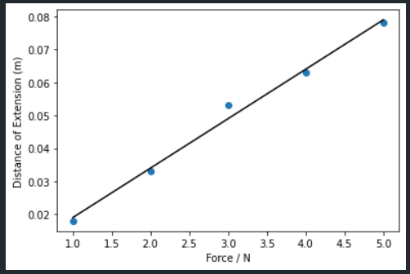
  + Gradient: 0.015
* We chose spring **2**

# Limit Switch Mount

## [v1] Initial Design

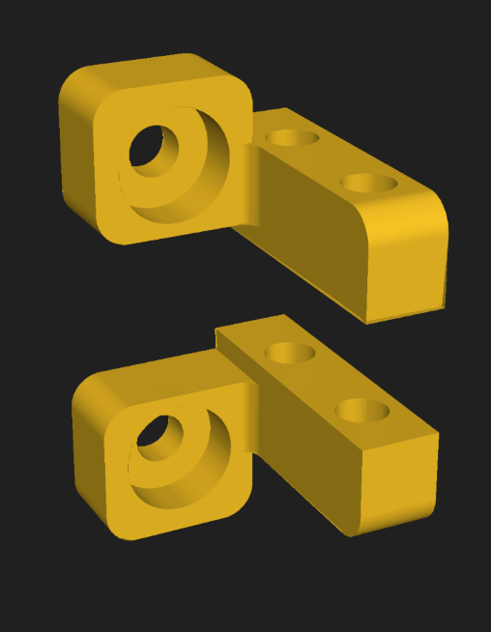

* Sandwiches limit switch in between
* 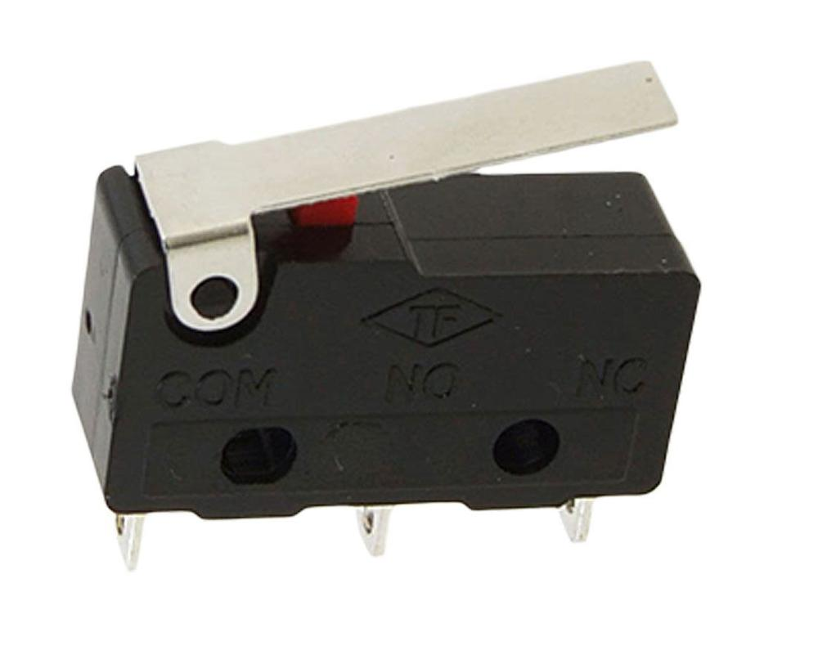
* 2 holes for screwing down limit switch
* 1 hole on each mount for screwing down to layer 2
* Mounted on bottom side of layer 2

## [v2] Merged limit switch mount with kicker mount

* Refer to *Kicker Mount [v5] FINAL*

# Servo Mount

## [v1] Initial design

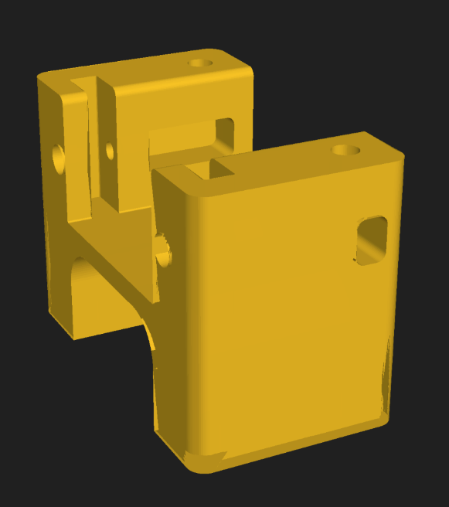

* Nut-less sandwiched design between layers 2 and 3
  + No nut reduces weight
  + Small circular indents to fit screw in
* Large rectangular cut-outs on the top and the bottom
* Top cut-out allows MG90 servo to be fitted in
  + Fits in along the slit cut-outs
  + Rectangular cut-out in the wall to fit a nut in to screw servo down
* Smaller rectangular cut-out on the other side
  + Fit servo wire through

## [v2] Increased wire routing hole

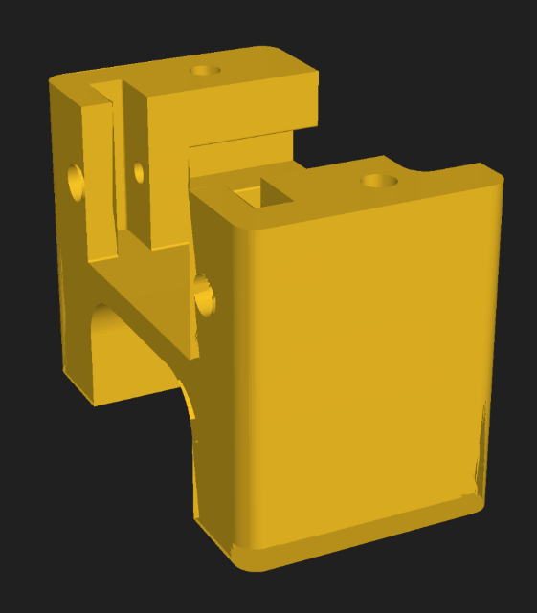

* Made wire-routing hole on the right side larger
  + Easier to pass wire through

## [v3] Shortened size

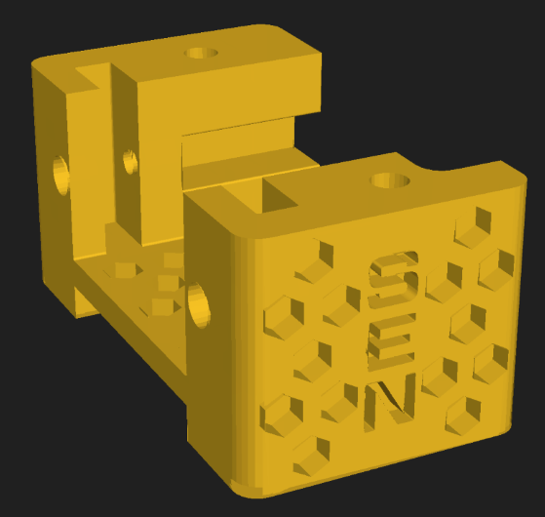

* Made servo mount shorter
  + Only mounts to layer 2 now
  + Does not touch layer 3 anymore
* Made various cut outs
  + Weight reduction
* Pushed cut-out in inner wall all the way through
  + Easier to insert nut
  + Reduce weight

## [v4] Symmetrical design

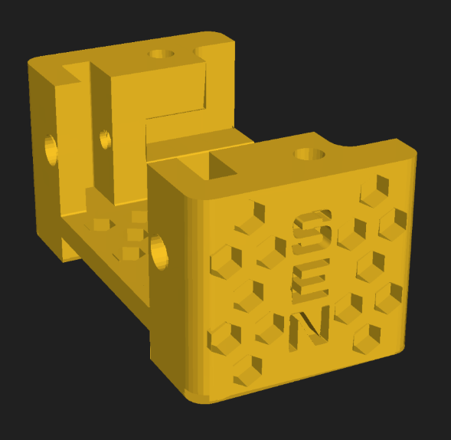

* Added identical mirrored wire-routing wire cut-out on other side
  + Reduce weight
  + Symmetrical design

## [v5] Removed entire top chunk

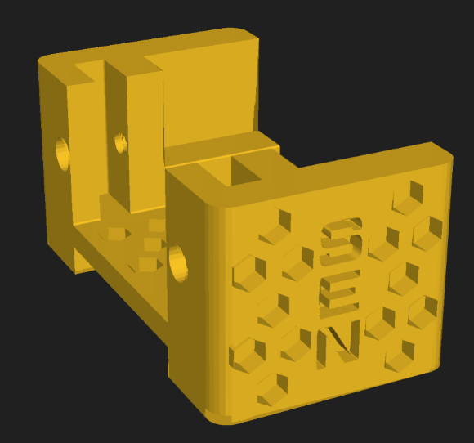

* Pushed the top part of cut-out in the inner walls all the way up
  + Easier to put screws
  + Less print material
  + Reduce weight

## [v6] Removed extra chunk of material on inner wall

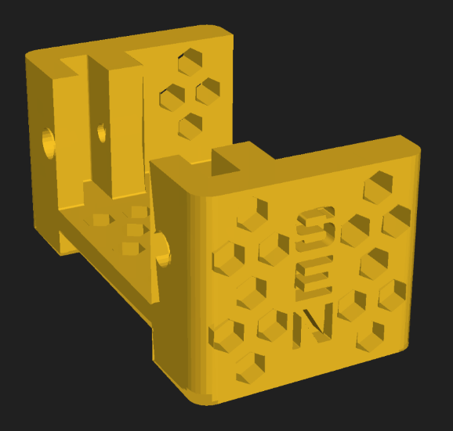

* Removed the entire chunk on the inside
  + Reduce weight
* Made hexagonal cut-outs in the walls
  + Reduce weight

## [v7] Removed walls

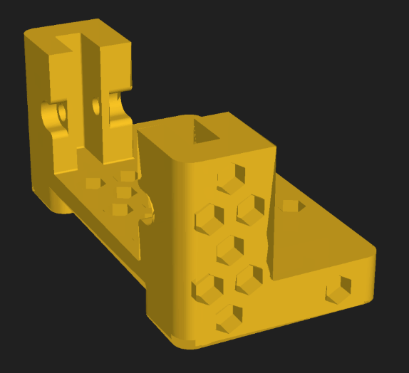

* Removed entire wall at the back
  + Reduce weight
* Lofted inset holes for screws for mounting servo
  + Prevents snapping

## [v8] Rounded bottom of servo mount

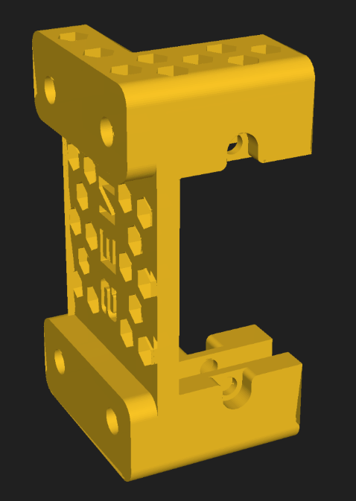

* Filleted bottom of servo mount
  + Smooth fit into cut-out in layer 2 onto layer 1.5

## [v9] **FINAL:** Unioned servo mount with layer 1.5

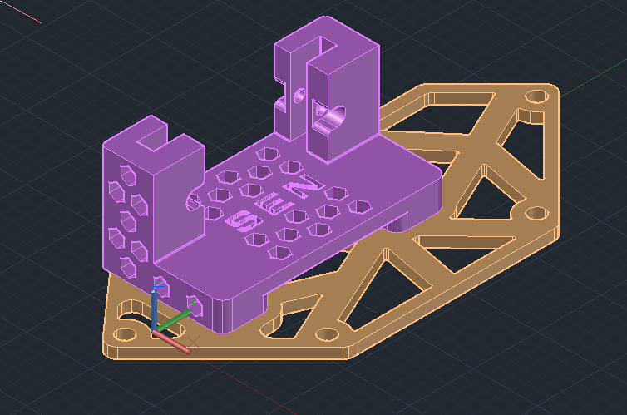

* Servo mount and layer 1.5 printed together

# Bearing Mount

## [v1] **FINAL:** Initial design

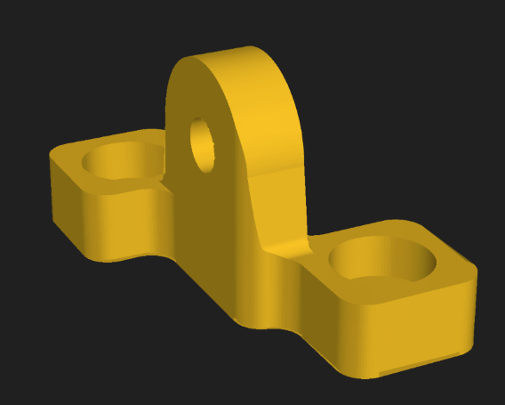

* 2 screw holes
  + Shares same holes as kicker mount
  + Less screws
  + Reduce weight
* Houses one bearing for axle

# Gear

## [v1] Initial Design

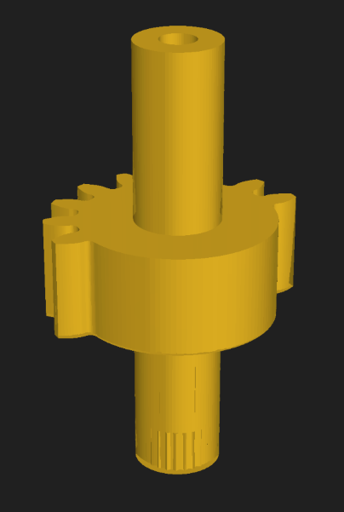

* Slip gear 10 teeth
* 2 cylinders at the side
  + Slot axle through the whole thing
  + One of the cylinders has a cut-out that fits the jagged shape on servo
  + Fit onto servo

## [v2] **FINAL:** Spilt up servo horn and gear

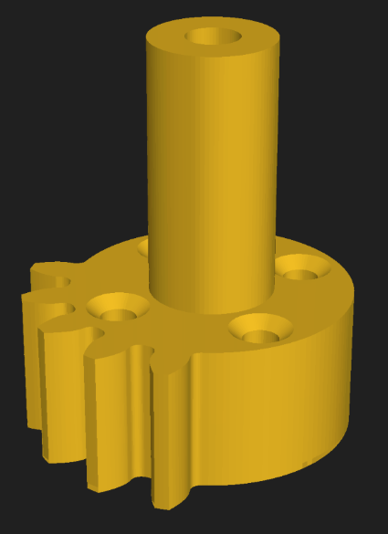

* Reduced to 5 teeth
* 4 holes for screwing in flathead screws into servo horn
* Cylinder for connecting to bearing mount
* Axle can pass through whole gear and servo mount

# Servo Horn

## [v1] **FINAL:** Initial design

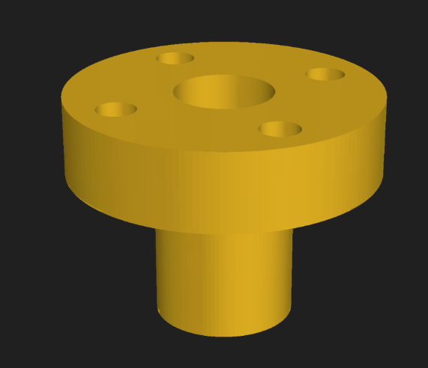

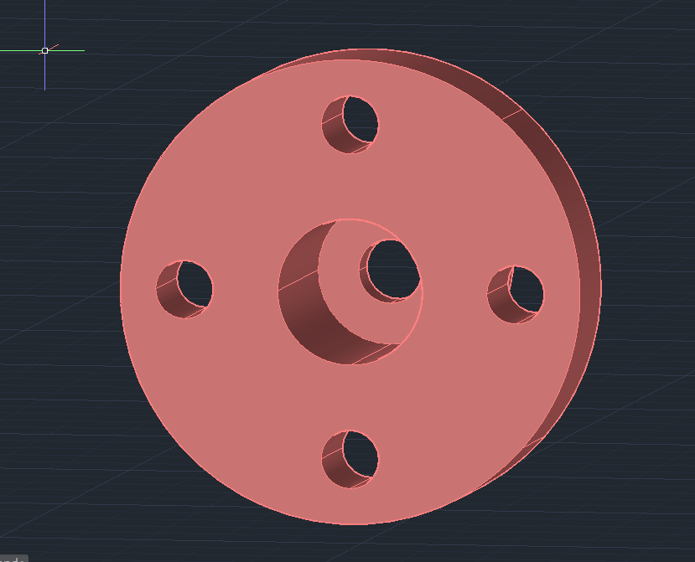

* 4 holes for screwing to gear
* Can be screwed down to servo first
  + 2mm screw through the large centre hole
* Afterwards then screwed to the gear with 4 2mm flathead screws
* Axle passes through hole thing and holds it in place

Mechanical (Layer 2): Dribbler System

# Motor

## [v1] Initial design

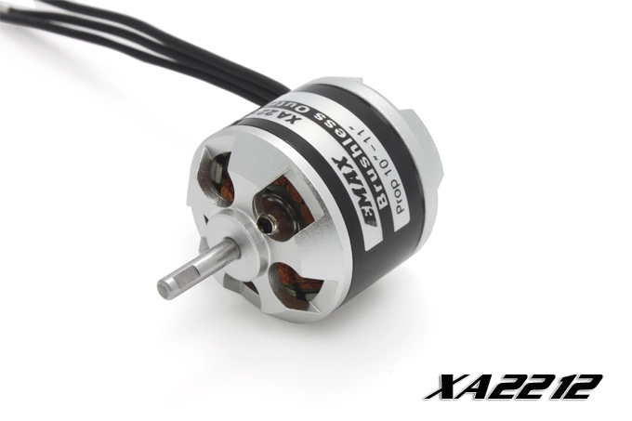

* EMAX XA2212 Brushless motor
* Heavy

## [v2] Changed to A2208

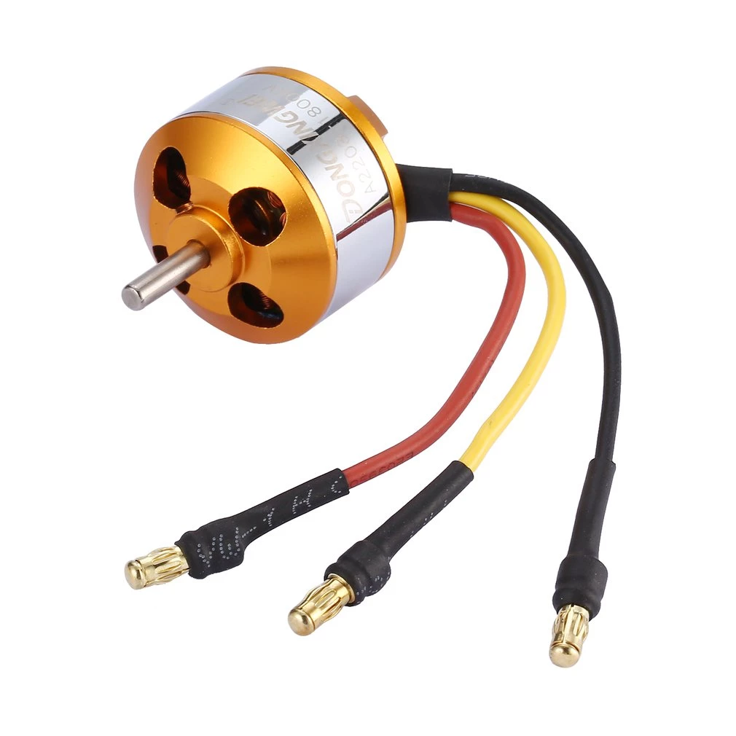

* A2208 Brushless motor
* Lighter compared to XA2212
* Sufficient speed

# Dribbler Body

## [v1] Initial design

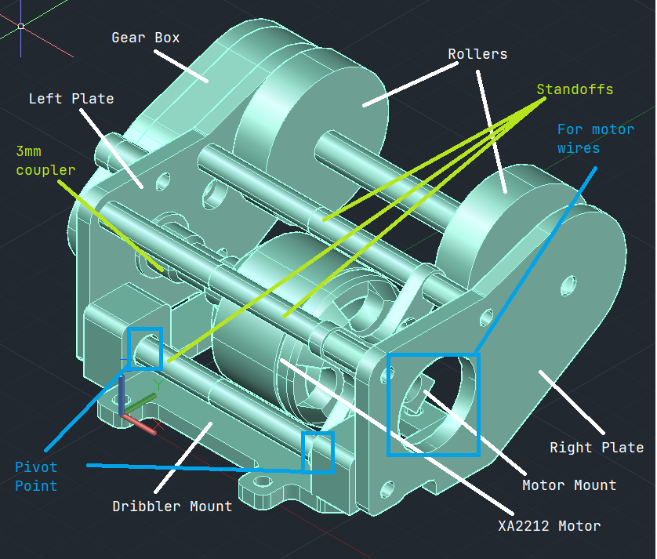

* Double roller design
  + More grip on the ball
* EMAX XA2212 Brushless motor
* Sandwiched between 2 plates

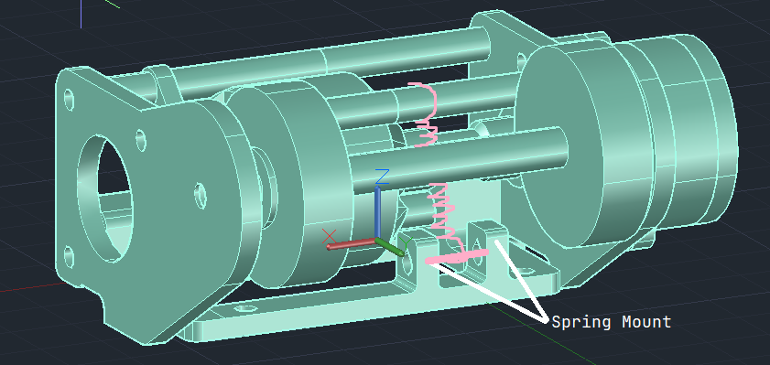

* Spring assisted mechanism
  + Allows dribbler to return to original position after engaging impact from ball

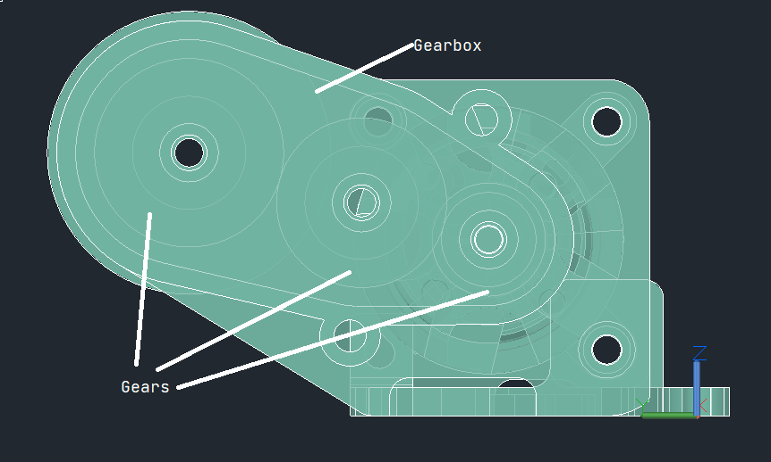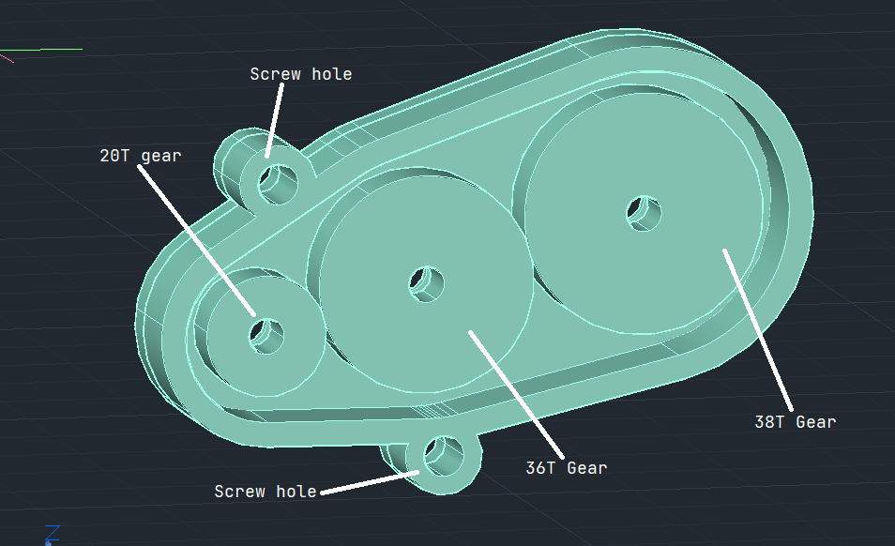

* Gears are modelled with pitch diameter
* Gearbox houses 3 gears
  + With bearings embedded in plates

## [v2] Flipped design / Changed motor to A2208

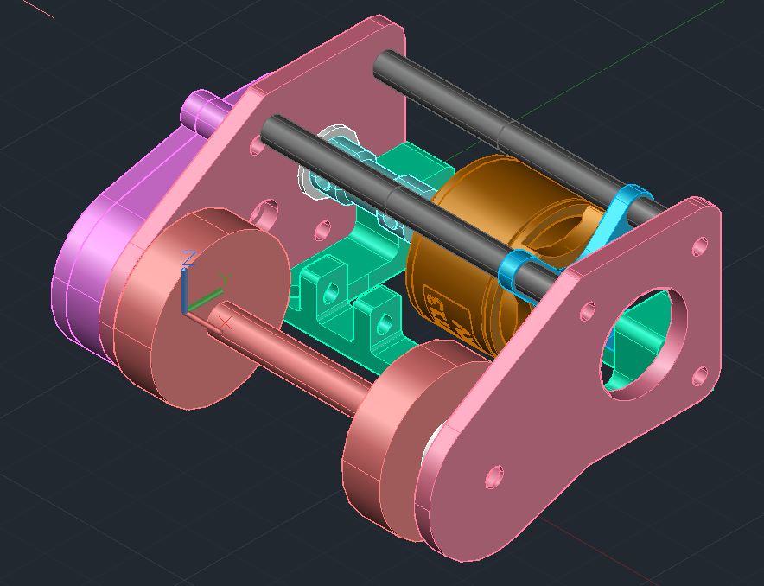

* Flipped original design
  + Rollers are now below layer 2
  + Previous design was adapted from last year
  + Could not reach the ball
* Motor changed to A2208
* Design is still not optimal

## [v3] Revamped entire design

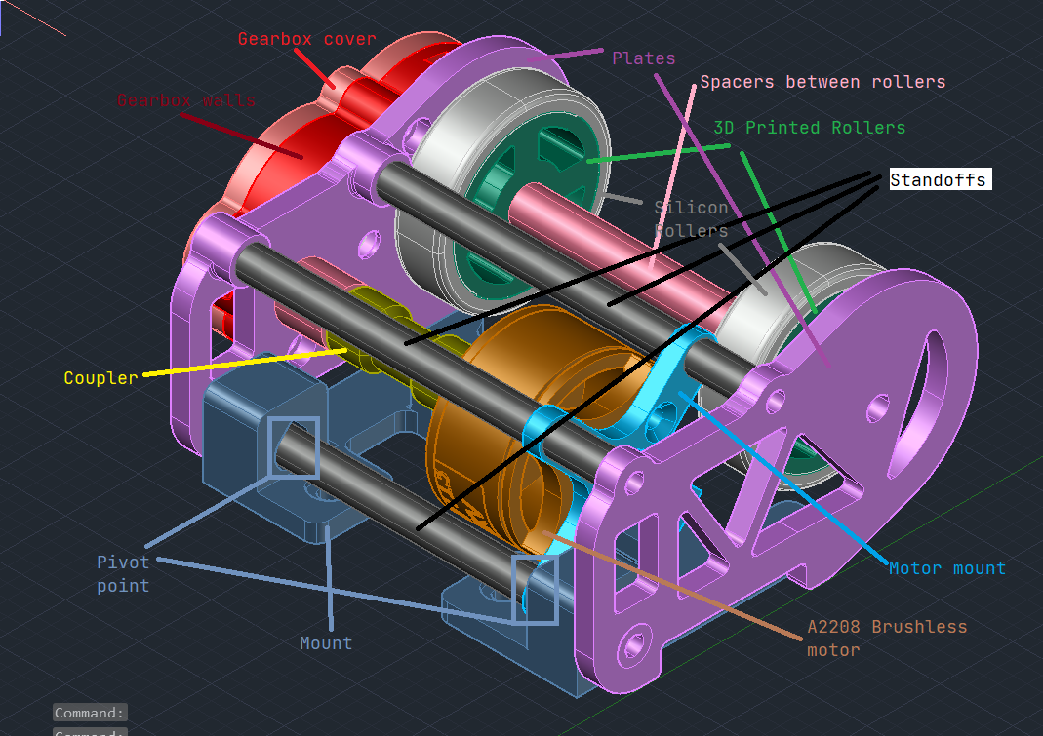

* Similar concept to old design

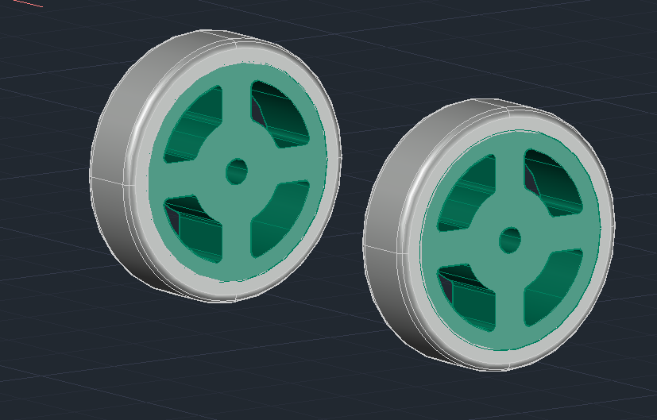

* 3D Printed Rollers with cut-outs
  + Maintain strength
  + Reduce weight and print material
* Silicon covering
  + Ensure good grip and friction on ball

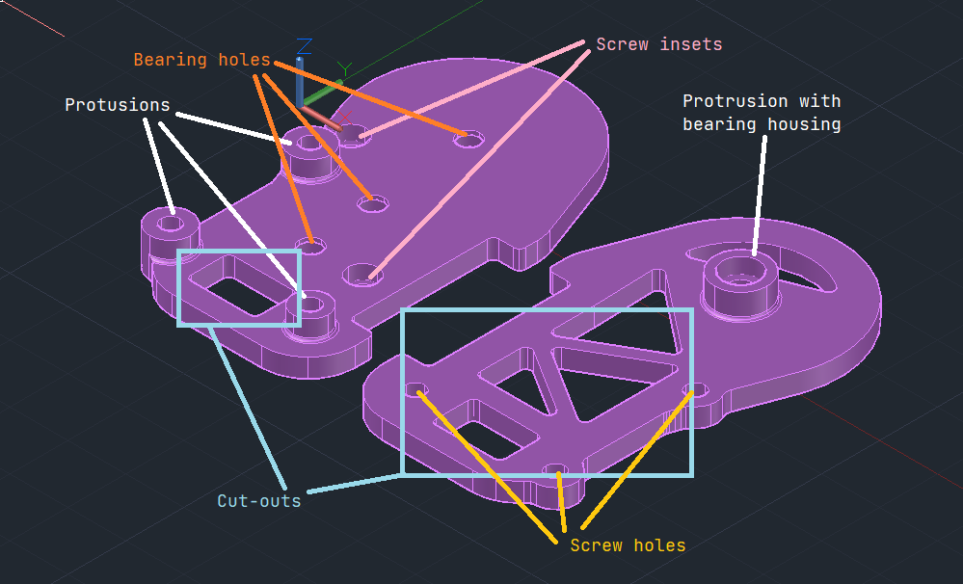

* Cut-outs
  + Reduce weight
  + Pass motor wires through hole
* Protrusions
  + Reach standoffs connecting plates and motor
  + Standoffs have fixed lengths that we can’t change
* 1 Protrusion with bearing
  + No need for spamming of washers
* Screw holes
* Bearing housings

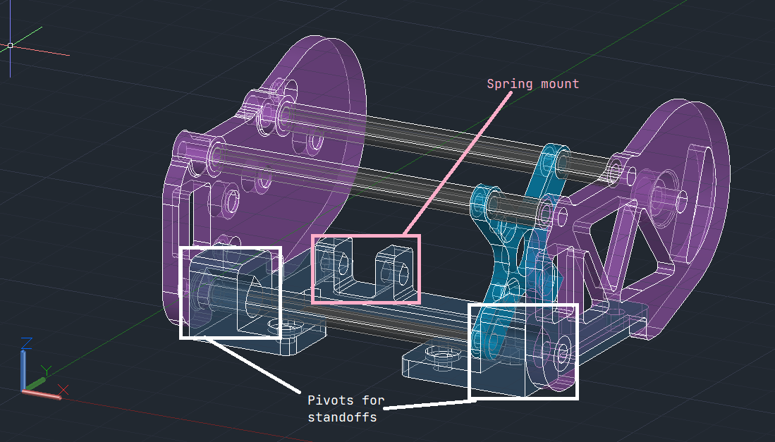

* Pivot points
  + Cylindrical hole
  + Lineage
  + Allows standoff to pivot smoothly
* Spring mount
  + Similar to [v1] Initial design

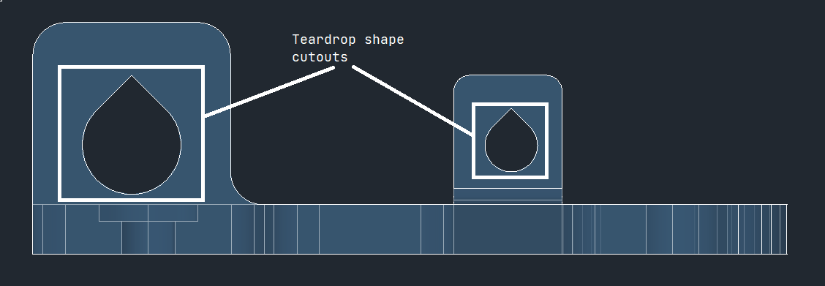

* Teardrop shape cut-outs instead of circular
  + 45 degree angle
  + Prevent supports during 3D printing (Overhang angle of more than 50 will have a support)
* No support allows for a smoother finish on the print
  + Smoother rotation and pivoting

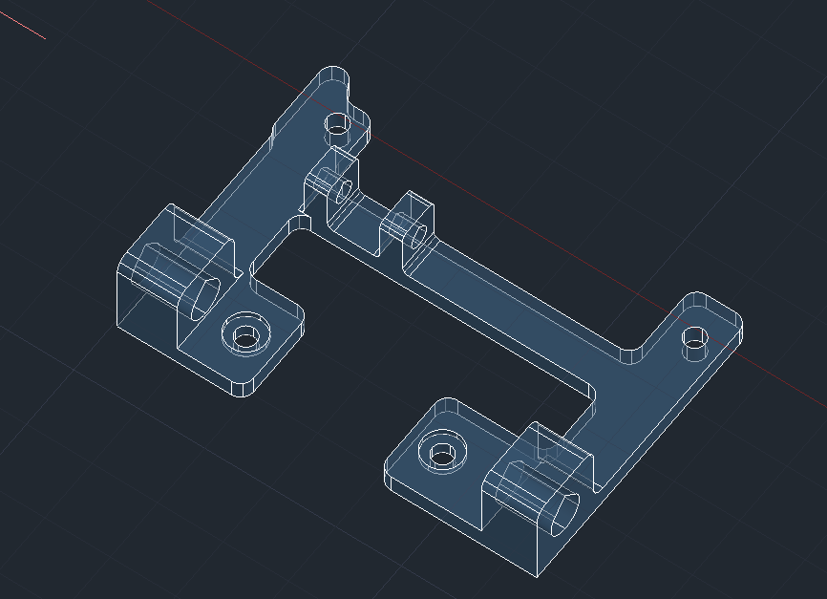

* Back screw hole have slightly indented holes
  + Screw will hit standoff

## [v4] Move holes forward on mount

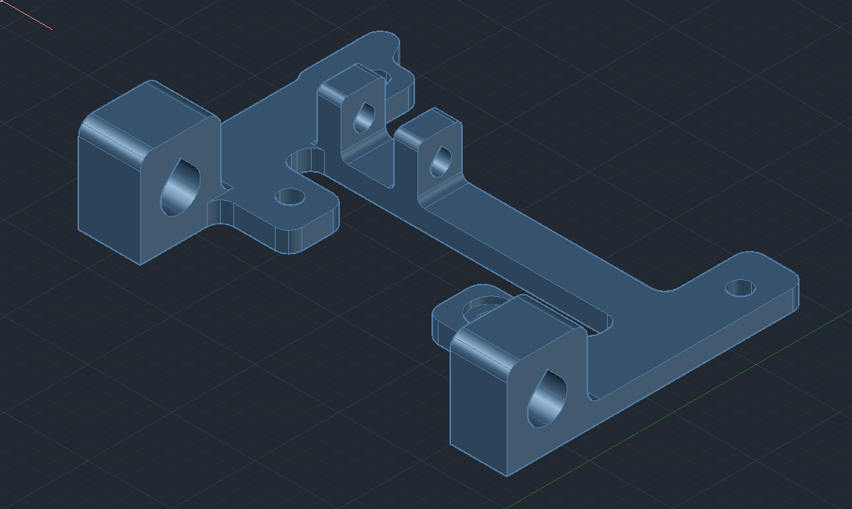

* Holes moved forward
  + Were not aligned with holes on layer

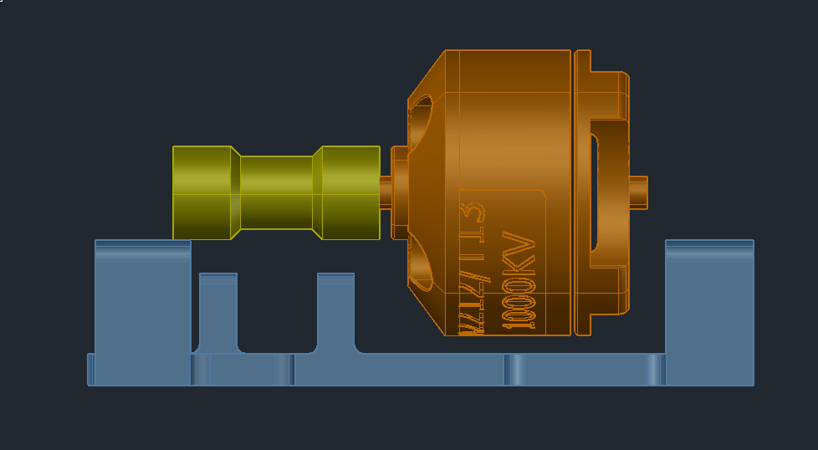

* Fixed issue of screw hitting motor on one side\

## [v5] **FINAL:** Made another protrusion on right plate

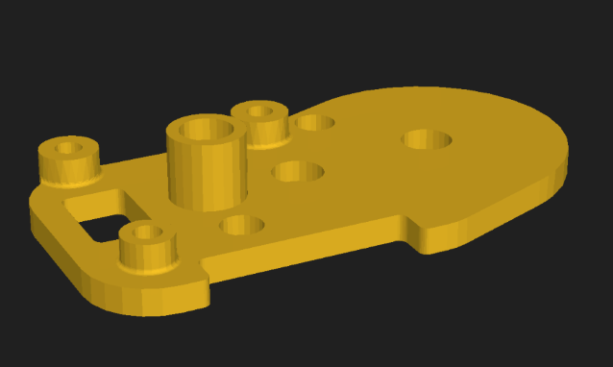

* Added protrusion
  + Avoid spamming of washers
  + Bearing mount integrated into protrusion

Mechanical (Layer 2): Battery Mount

# Mounting Part

## [v1] Initial design

* 4 standoffs connected to layer 1
* Floating above layer
* Hole in layer 2 to allow battery mount to fit

## [v2] Minor change - Not captured

* Went through many designs with smaller friction fit holes
  + Weak

## [v3] **FINAL:** Layer 2 mount with friction

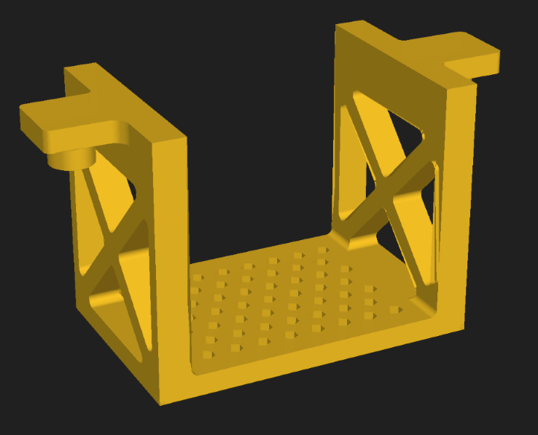

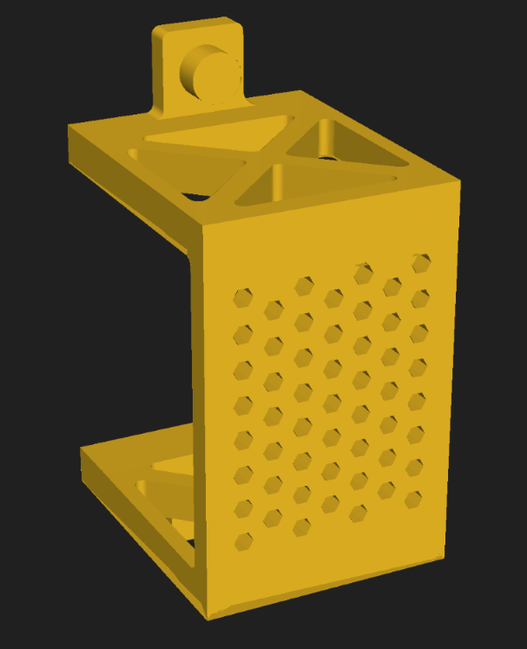

* Mounted from layer 2
  + Sinks through a large rectangular hole in layer 2
  + Friction mounting with 2 cylinders with respective holes on layer 2
  + Refer to Layer 2 [v15]
* Cut-outs on the side
  + Reduce weight
  + Maintains integrity
* Hexagonal cut-outs on the bottom
  + Reduce weight
  + Stills allow battery to rest on it

Mechanical (Layer 4): Mirror

# Mirror skeleton

## [v1] Initial design

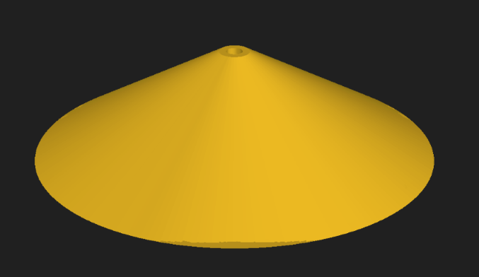

* Screwed onto layer 4 with a standoff
* 3D printed
* Covered with thin mirror sheet

## [v2] Merged with layer 4

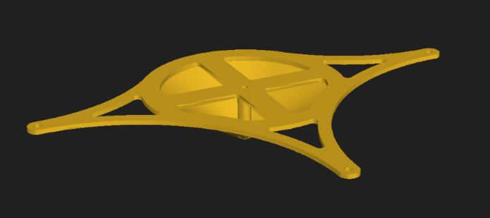

* Whole laye 4 will be 3D printed with mirror
* Cut-outs to reduce weight
* 3 holes around side to screw to standoffs connecting to other layers
* Mirror cone shaped below layer
  + 3D printed stand off to maintain integrity
* Thickness: 1.6mm

## [v3] Removed centre area

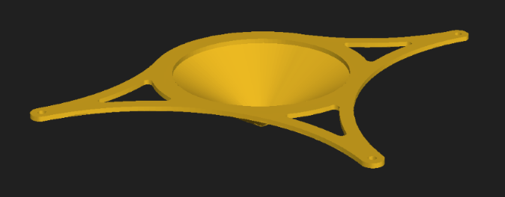

* Removed T section in the centre
* Removed standoff

## [v4] Cut holes in cone

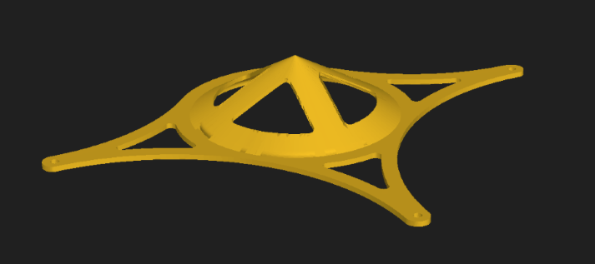

* Made quadrant cut-outs in the cone

## [v5] Made layer 2mm thick

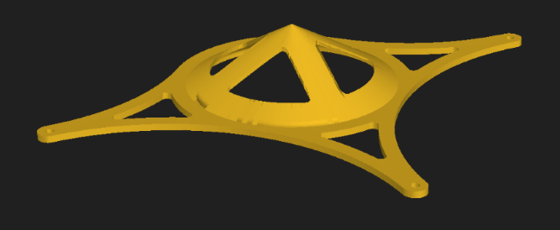

* Made layer 4 2mm thick

## [v6] **FINAL:** Changed back to [v1] with PCB Layer 4

* Changed back [v1] cone design
* Screw down with standoff to layer 4
* Needed to add ultrasonic sensors to layer 4
  + Changed back to pcb design

Layer designs (Electrical)

# Layer 1 PCB